- Register
- Login
- Home /
- Archives /
- Vol 4 No 02 (2018): Desember 2018 /
- Article

KEPEMIMPINAN PROFETIK DALAM PERSPEKTIF MANAJEMEN PENDIDIKAN ISLAM
- Wasehudin Wasehudin UIN Sultan Maulana Hasanuddin Banten
DOI: http://dx.doi.org/10.32678/tarbawi.v4i02.1234

Abstract
Leadership is the main pillar in organizing an organization. The success of Islam as a divine religion will no be separated from the personality of a figure who has high integrity and capability. Muhammad as a figure, the Prophet and the Apostle is a rule model in managing (designer) teliabel all forms of life from family, community to head of state. In Jalaluddin Rachmat’s pint of view there are two forms in dealing with Islam: both textual and the second contextual. The conceptual Islam is Islam contained in the Qur’an as a revelation whose truth will be left when the interpreters are able to understand it in the present context. While the actual Islam is a smart and brilliant idea how to display the figure of Islam is cool, harmonious, and full of peace. Showing such Islam is an unattached portion of a reliable managerial figure in which the pattern of enforcement of juistice as the basis of the all-embracing idealism has been termed by Kunto Wijoyo in which the managerial arrangement of social, political, managerial directed to a transformative order in which Islam and management constitute a united whole in order to organize social life.

Keywords. Leadership, Islam, Education, Prophetic.

Downloads
Download data is not yet available.
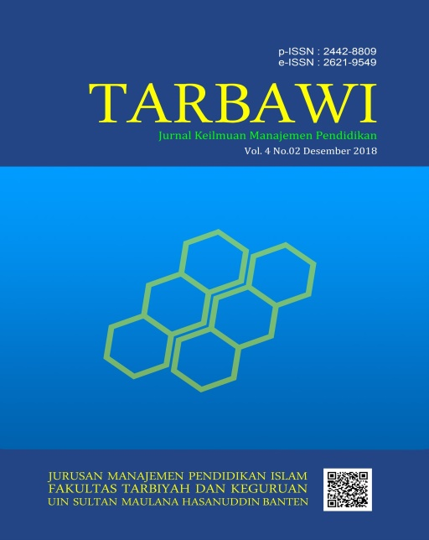
- PDF
Published
Dec 18, 2018
How to Cite
WASEHUDIN, Wasehudin. KEPEMIMPINAN PROFETIK DALAM PERSPEKTIF MANAJEMEN PENDIDIKAN ISLAM. Tarbawi: Jurnal Keilmuan Manajemen Pendidikan, [S.l.], v. 4, n. 02, p.

227-236, dec. 2018. ISSN 2621-9549. Available at: <http://jurnal.uinbanten.ac.id/index.php/tarbawi/article/view/1234>. Date accessed: 06 feb. 2019. doi: http://dx.doi.org/10.32678/tarbawi.v4i02.1234.
Citation Formats
- ABNT
- APA
- BibTeX
- CBE
- EndNote - EndNote format (Macintosh & Windows)
- MLA
- ProCite - RIS format (Macintosh & Windows)
- RefWorks
- Reference Manager - RIS format (Windows only)
- Turabian
Issue
Vol 4 No 02 (2018): Desember 2018
Section
Article
Language
- English
- Bahasa Indonesia
Information
- For Readers
- For Authors
- For Librarians
Make a Submission
Indexed by

Counter

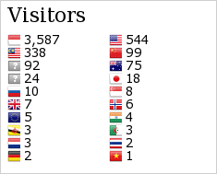
Publisher

Jurusan Manajemen Pendidikan Islam, Fakultas Tarbiyah dan Keguruan,
UIN Sultan Maulana Hasanuddin Banten,
Jl. Syech Nawawi Al-Bantani Kp. Andamui Kel. Sukawana Kec. Curug Kota Serang
E-mail: tarbawi@uinbanten.ac.id
© 2017 - Univeristas Islam Negeri Sultan Maulana Hasanuddin Banten | Powered by : OJS 3.0.1

