CHAPTER III

METHOD OF THE RESEARCH
- RESEARCH METHOD
The following definition, taken from Aliaga and Gunderson (2002), describes what we mean by quantitative research methods very well:
Quantitative research is ‘Explaining phenomena by collecting numerical data that are analyzed using mathematically based methods (in particular statistics).’
According to the statement above that quantitative research is research that uses numbers or count to analyze.
Quasi-experiments are often used precisely because such random allocation is not possible or practical. Typically, the experimental group will be decided by which settings (e.g. schools, classrooms, factories) have volunteered or been selected to be part of the intervention.
Based on above statement that the quasi experiment is often used as practical or simple usually class or group experiment can determine or set in which the location or a place like schools, classrooms, or factories and occurs voluntarily without force.
The writer chooses the non equivalent control group design in this research, according to Donald ”one of the most widespread experimental designs in educational research involves an experimental group and a control group both given a pretest and a posttest, but in which the control group and the experimental group do not have pre-experimental sampling equivalence.
based on the above statement that the non-equivalent control group design is one of the most extensive experimental design in conducting research in the field of education, and therein involves the experimental class and control class and given a pretest and posttest. But the control class and experimental class did not have a pre-experimental equivalence.
The writer will be divided 2 classes as the object of the research to be experiment class and control class. X IIS 2 as an experiment class that is using new method from the writer, and X IIS 4 as a control class that is using old method from the school. And then the writer will be compare the effectiveness in learning process between X IIS 2 and X IIS 4 is there a development decrease in both classes in vocabulary learning.
32
- POPULATION AND SAMPLE
- POPULATION
A population is commonly understood to be a natural, geographical, or political collection of people, animals, plants, or objects. At SMAN 19 Balaraja Kabupaten Tangerang there is put 20 classes and divided into: 10 classes of first, 4 classes of second class IPA, and 6 classes of second class IPS. The first class content 400 students are taken as the population in this research. So the writer takes 15% from the population above for the research.
- SAMPLE
In statistics and quantitative research methodology, a data sample is a set of data collected and/or selected from a statistical population by a defined procedure.. In this research writer took sample research 2 classes from first class (X IIS 2 and X IIS 4). X IIS 2 class content 38 students as experiment class and X IIS 4 class content 38 students as control class.
The writer used stratification technique as sampling technique because In educational research and other social research, often encountered conditions of the population is composed of several layers or groups of individuals with different characteristics. Most appropriate technique and has a high accuracy is a sampling technique by means of stratification. This stratification technique should be used early on, when the researchers know that the condition of the population consists of several members who have stratification or layer different from one another. The accuracy of stratification technique can also be improved by using the proportional size of the layer members is determined by the population size of the number of members of the population in the existing layer.
- INSTRUMENTS
- Instruments for Treatment
Instruments for treatment in this research are observation, test, and interview were conducted in order to know how the students’ score after they are taught using scrabble game, To complete and support the data, the writer did documents of teaching-learning process.

- Students’ Scrabble Game Scoring Sheet
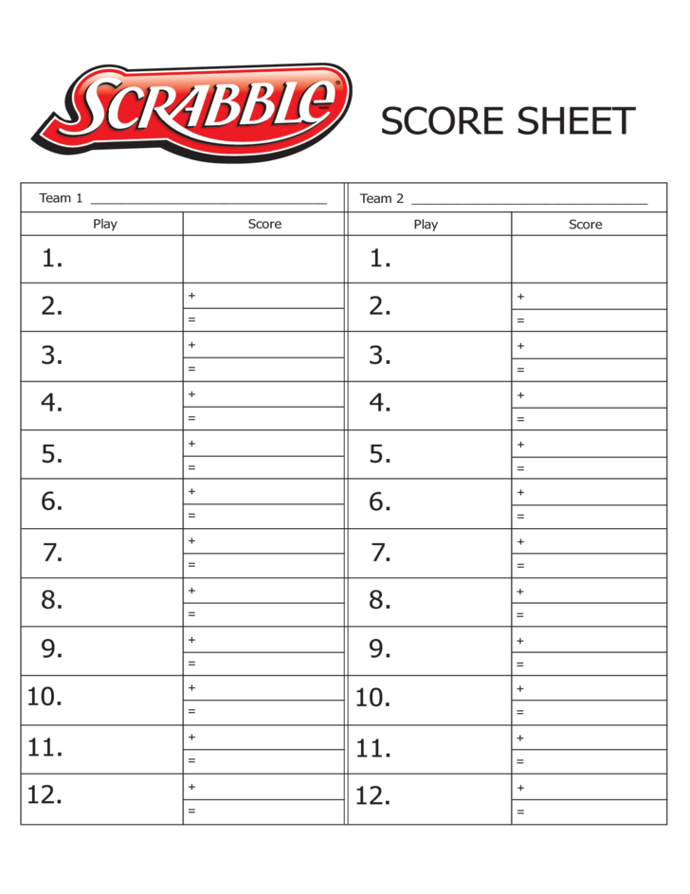
This scrabble score sheet is intended for two group games (print more if you have more contenders) and includes an illustration of a board game as well as list of letter to check off once used.

- Board Scrabble Game
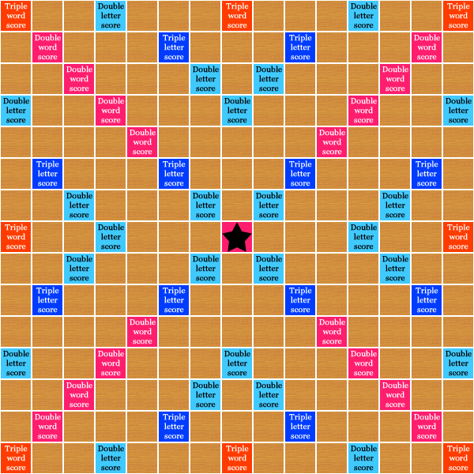
The board is marked with “premium” squares, with multiply the number of points awarded: eight dark red “triple-word” squares, 17 pink “double-word” squares, of which one, the center square (H8), is marked with a star or the other symbol; 12 dark blue “triple-letter” squares.
- DATA COLLECTION AND DATA ANALYSIS
- Data Collection
Data collection is the process of gathering and measuring information on targeted variables in an established systematic fashion, which then enables one to answer relevant questions and evaluate outcomes. In collecting the data the writer do some steps, such as:
- Observation
According to Diana and Steve, “Observation is often used in combination with a range of other methods of data collection”. The writer observes to the location where the research was carried out. The purpose of this observation is asking permission of the headmaster to do research at his place, by observation the writer can know the situation they directly is available or not.
- Test
Davies (1968: 5) in Arthur Hughes’s book “Testing for Language Teacher” the good test is an obedient servant since it follows and apes the teaching.
The second step of collecting data is testing by the end of study. The writer gave some vocabularies test. The total numbers of test is about 25 numbers. The writer takes the data by using instrument test (pre-test and post test).
- Interview
The writer is sure that the interviewing technique is the process of asking questions to the teacher of English. Interview is conducted to find out the real condition of senior high school at SMAN 19 Balaraja Kabupaten Tangerang.
- Data Analysis
In this research, the writer wants to compare result of the research between experiment class and control class students, the writer took step as follow:
- The result of the post-test in experimental class is named variable (X1)
- The result of the post-test in control class is named variable (X2)
- Qualification of data: translation
- Pre- test consist of list vocabularies, for all question the correct answer is given score 4 (four) and incorrect answer is 0 (zero). The total items are 25 (twenty five) items from 25 (twenty five) question.
- Post- test consist of list vocabularies, for all questions the correct answer is given score 4 (four) and incorrect answer is 0 (zero). The total items are 25 (twenty five) items from 25 (twenty five) questions.
The steps for statistic analyze are:
- Investigating students worksheet give and describes score in the table
- Determining mean of variable X with formula:
$$M_{X}= \frac{∑_{X}}{N}$$

- Determining mean of variable Y with formula:
$$M_{Y}= \frac{∑_{Y}}{N}$$
- Determining derivation score variable X with formula:
X = X2-Y1
- Determining derivation score variable Y with formula:
X = Y2-Y1
After getting the data from pre-test and post-test, the writer analyze it by using statistic calculation of t-test formula with the degree of significance 5% and 1 % the formula as follow:
t = $\frac{Mx-My }{\sqrt{\frac{∑X^{2}+∑Y^{2}}{Nx+Ny-2}\left[\frac{1}{Nx}+\frac{1}{Ny}\right]}}$
T = test
M = means of each group from the deviation
X = the deviation of every $X_{1 }$and $X_{2}$
Y = the deviation of every $Y_{1 }$and $Y_{2}$
N = number of students
- Doing interpretation and conclusion by comparing the result of calculation t-test with t-table.

- RESEARCH PROCEDURE
- Preparation
Play on the front board. A variation is a relay race, with 2 members from each team working together. A clue to the vocabulary item is given. One student searches for the letters. The other student places them on the board. First team to get the word correctly spelled wins the point.
The above statement saying that the extents to which learners enthusiastic about learning vocabulary with a game of scrabble and remember and digest each vocabulary that is placed in the board.
- Research Implementation
As a field research, the location is importance in the research and this research, the writer choose the place research in senior high school (SMAN 19 Balaraja Kabupaten Tangerang). It is located in Jl. Raya Kresek, Km. 1.5, Balaraja, Kabupaten Tangerang 15610, Banten, Indonesia. And will hold this research on 30 August 2016. This location is more comfortable to learn however it’s located near from Traffic Street and also the condition is good.

Daniel Muijs, Doing Quantitative Research in Education, (London: Sage Publication, 2004), p. 1.
Daniel Muijs, Doing Quantitative Research in Education, (London: Sage Publication, 2004) p. 26-27.
Donald T. Campbell & Julian C. Stanley, Experimental and Quasi-Experimental Designs for Research, (London: Houghton Mifflin Company, 1963), p. 47
Shirley Dowdy, et al., Statistics for Research Third Edition, (New York: Wiley Inter science, 2004) p. 25.
https://en.wikipedia.org/wiki/Sample_%28statistics%29
http://www.formsbirds.com/formimg/scrabble-score-sheet/7577/scrabble-score-sheet example-l1.png
http://interactive.usc.edu/wp-content/uploads/2011/08/board.png
https://en.wikipedia.org/wiki/Data_collection
Diana and Steve, Practitioner for Teacher, (London: Sage Publication, 2005), p. 138.
Arthur Hughes, Testing for Language Teachers, (United Kingdom: Cambridge University Press, 1989), p. 2.
http://www.nclrc.org/teachers_corner/classroom_solutions_yana/vocabulary_activities.html,op.cit.

