THE EFFECTIVENESS OF USING SCRABBLE GAME
ON STUDENTS’ VOCABULARY
(An Experimental Research at the First Grade of SMAN 19 Balaraja Kabupaten Tangerang)

A PAPER

Submitted to the Department of English Education,
The Faculty of Education and Teacher Training as a Partial Fulfillment
of the Requirement for the Sarjana Degree

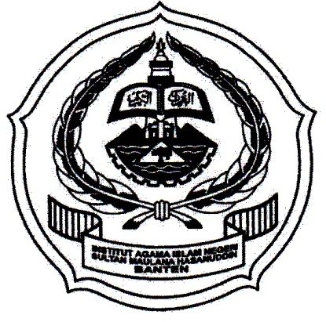

By:
DEWI APRILIANI
SRN: 122301217

FACUTY OF EDUCATION AND TEACHER TRAINING
THE STATE INSTITUTE FOR ISLAMIC STUDIES
SULTAN MAULANA HASANUDDIN BANTEN
2016 A.D / 1438 A. H

