CHAPTER III
METHODOLOGY OF RESEARCH

- The Method
    - Research Design
The researcher has closen Classroom Action Research (CAR) to conduct this researcher, because CAR is and effective and suitable method to apply the Implementation of Mind Mapping Technique to Improve students speaking skill at the seventh grade students of MTs At-Toyibah Curuglemo.
Action research is a name given to a particular way of researching your own learning. According to David Nunan, action research is a form of research is becoming increasingly significant in language education.
From the definition above, this research is conducted in order to know Implementation of Mind Mapping Technique to Improve students or not and to know the process of Implementation of Mind Mapping Technique to Improve students. CAR is simple research to solve the problem in classroom activity usually done by a teacher. This is based upon the reason that the researcher attempled to solved her personal practical problems faced in the classroom. Classroom action research (CAR) is a research that conducted by the teacher to save the problem of the student that is done by herself, it means that classroom action research is process through which the teacher studies their own teaching in order to solve their personal practical problems. Kemmis and Mc.Teggart State, “Action research is a form of collective self reflective enquiry undertaken by participants in social situations in order to improve the rationality and justice of their own social or educational practice, as well as their understanding of these practices and the situation on which these practices are carried out.”
Therefore, the procedure of classroom action research applied in this research was a cyclical process adapted from the model proposed by Kemmis and Mc Teggart, It covers four steps:
- Plan
Like teaching, planning is the first of the action research process. When planning a lesson, teachers establish learning goals, create an assessment plan, and design their instructional activities. When planning an action research study, teachers should decide on the goals and purposes of the study, decide on a research question to guide the study, select the research participants, and determine the method of data collection.
- Collection Data (Action)
During the data collection, action are taken to carry out your action research project. This action includes implementing new teaching strategies and collecting data on them. Collection could include administering tests and observing studens.
- Analyze (Observation)
Observation is activity to collect data that is related to the application of writing, the strategies and the way of teacher in solving the problem and student’s work. Observation will be done during the teaching and learning and learning process is conducted.
- Reflection
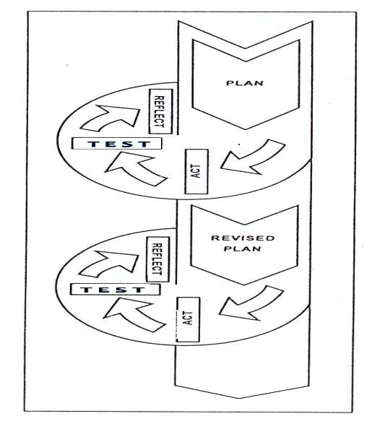
Reflection is activity to evaluate the material with student. In this part, the researcher know how far the progress of students’ understand about the material. Reflection process is to justify new teaching strategies by supporting them with data, best practice, educational research, or educational theory. In conducting the classroom action research, the researcher uses four steps to be clearer, see the figure below.
Figure 3.1
Four Steps of Classroom Action Research
In this classroom action research, the researcher conducts two cycles. It means when the researcher has finished conducting the first cycle, and the result of study has not been improved yet, or there are any problems that have not solved, then the researcher continued to conduct the second cycle. Both the first cycle and the second cycle use the same procedure which consist of planning, acting, observing, and reflecting. Those are the description:
Cycle 1
Step 1 : Planning
- Preparing the lesson
- Giving the pre test
- Preparing the material from tekt book
Step 2 : Acting and observing
- Handling out practice material by using mind mapping technique
- Let the student to explore their speaking skill by using mind mapping technique
- Giving speaking test 1 to the students.
Step 3 : Reflecting
- Doing the evaluation
- Evaluating the observation
- Doing evaluation of acting 1

Cycle 2
Step 1 : Planning
- Preparing the lesson plan
- Preparing the material
- Collecting the previous data (score of speking test)
Step 2 : Acting and observing
- Handling out practice material about speaking test by using mind mapping technique
- Let the students explore their speaking skill by using mind mapping technique
- Giving speaking test 2 to the students.
Step 3 : Reflecting
- Doing the evaluation
- Evaluating the observation
- Doing evaluation of acting 2

- Place and Time
In this research the writer take a place for research at MTs At-Toyibah is located Jalan Ciomas Km 05 Kampung Cilimus Luhur Desa. Curuglemo Kec. Mandalawangi Kabupaten Pandeglang Provinsi Banten. The writer does the research at the seventh grade of MTs At-Toyibah Curuglemo as the subject or place of the research. The writer will be starting the research at January 2018 until finish the research.

- Population and Sample
1. Population
Poulation is all cases, situation,or individuals who hare one or more characteristics. A population is commonly understood to be natural, geoghraphical, or political collection of people, animal, plants, or subject. The population of the research is the seventh grade of junior high school MTs At-toyibah 2017/2018 consist of 81 students.
    - Sample
Sample is a subset of individuals or cases from with in a population. sample in this research use a subset of all cases in population in this research is 25 students.

- Instrument for Collecting Data
The instruments that will be used in collecting data are :

- Observation
The researcher will be observe the students, teacher and classroom, and take note all things that related to the research by using observation format.
- Test
Test is include as part of the learning process. The success of a lesson can be seen from the test result. Test will be used in this research in an oral exam form because of the skill is speaking. The method of testing is different with another.

- Technique For Analyzing Data
After the collecting the data, the writer will analyse the capability of the students by using some criteria. According to Syakur (1987:3,cited in Yultisa and Yani, 2013:3), there are at least five components of speaking skill concerned with comprehension, grammar, vocabulary, pronunciation, and fluency.

Table 3.1
The Rating Scale of Oral English
No | Criteria | Comment | Score
1 | Pronunciation, grammar , vocabulary, fluency and comprehension | Very good | (5)  90 – 100
2 | Pronunciation, grammar , vocabulary, fluency and comprehension | Good | (4)  80 – 89
3 | Pronunciation, grammar , vocabulary, fluency and comprehension | Enough | (3)  70 – 79
4 | Pronunciation, grammar , vocabulary, fluency and comprehension | Less | (2)  60 – 69
5 | Pronunciation, grammar , vocabulary, fluency and comprehension | Low | (1)  50 – 59

Category very good = 90-100, good =80-89, enough = 70-79, less = 60-69, and low = 50-59 .
If the implementation of the first cycle of students does not achieve exhaustiveness 85%, it means the first cycle is fail, and the research will be continued to second cycle with the same material to reach the exhaustiveness of learning by using the same formula.
There are two points that will be used in this research to measure the success of this classroom action research:
- Individually
Every student should reach the Minimum Completeness Criteria (KKM) in speaking skill (based on the school KKM rules).
- Classically
At least 85% of the class should reach the Minimum Completeness Criteria (KKM) or more.
To find the mean score, the researcher used the formula as follows :
Mean/µ = $\frac{\sum{fx}}{N}$
Note :
$M_{x}$ = Mean score
`$f_{x}$ = The Students’ score
∑ = The sum of score
F = The number of student

David Nunan, Research Method in Language Learning. USA: Cambridge University Press, 1992, p.17
Kemmis, &McTeggart, R. The Action Research Planner.3rd ed. Victoria, Australia: Deakin University. 1983.p.231
. Nunan, Research Method in Language Learning, 231
Nunan, Research Method in Language Learning, 232

