AN ANALYSIS OF STUDENTS’ ERROR IN USING PERSONAL PRONOUN ON WRITING DESCRIPTIVE TEXT
(A Case Study of the Second Grade of MA BanyNawawi
Gelereng-Cilegon)

A PAPER
Submitted to English Education Department
The Faculty of Education and Teacher Training
As a Partial Fulfillment of The Requirement for Sarjana Degree

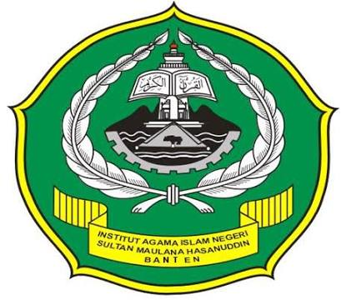

By:

RIMA IRMAWATI
SRN. 122301373

FACULTY OF EDUCATION AND TEACHING TRAINING
THE STATE INSTITUTE FOR ISLAMIC STUDIES
SULTAN MAULANA HASANUDDIN BANTEN
2016 A.D/ 1438 A.H

