CHAPTER I
INTRODUCTION

- Background of the study
Language is the embodiment of human desire to keep in touch each other and expressing the ideas. In other words, language is a tool for communication. Like James D. William wrote “Language is a paramount, we use it to define who we are and to shape our place in life. We use it to learn, to socialize, to dream, to think, etc. throughout history, language has served as a bond to bring people together into single societies and to preserve their customs, culture, law and stories. We also use language to get this done”. In expressing ideas, people need language to make it understood by others whether it spoken or written.
In the global era, we can’t avoid to make global communication. There were a thousand language which used by a million people over the world. English is one of the most used language in the world for communication purposes. English is not only used as spoken language but also used as written form in technology, commerce and education fields, etc. In Indonesia, English is the foreign language and it is taught as a compulsory subject in junior and senior high school, even till university there is English department as the evidence of the awareness of the Indonesian government in knowing that learning English is not an easy thing.
Indonesians know that needed hard effort to mastering English because there is a lot of differences between Bahasa and English, especially in its grammatical structure as well. For some people, spoken language is the effective way to convey and derive information and for the other it can be hard to speak but well in written. For people who like expressing their ideas through writing, at least they need a paper and a pen to support their ability. However they also need boarder knowledge in linguistic rules.
Writing in English is the harder one in English skills. Besides we have to know well the sentence grammatically, we also have to be able represent our ideas clearly. Writing is not only making a sentences which have no inter-connection each other or without mind the linguistic aspect in its process. But writing is the process of pouring a whole writers’ ideas into meaningful pieces.
There is no doubt that writing is the most difficult skill for L2 learners to master. The difficulty lies not only in generating and organizing ideas, but also in translating these ideas into readable text. “L2 writers have to pay attention to higher level skills of planning and organizing as well as lower level skills of spelling, punctuation. word choice, and so on. The difficulty becomes even more pronounced if their language proficiency is weak.” So, The skills involved in writing are highly complex.
Nowadays, the need of writing is unavoidable. A demand of globalization era toward global knowledge has been increasing quickly. People should be able to make a writing product in English as a requirement of job, academic degree, and even self opinion toward social phenomenon.
An essay is one of writing product. “An essay made up of a group paragraphs about one subject. –it has three main parts: the topic sentence, the body, which is made up of supporting sentences, and the concluding sentence.” “Essay writing is at the heart of education. Students at every level need to be able to write clear and well-organized essays whether in the form of private note, assignments, dissertations or examination answers.” In the other word, people should be able write an essay.
A short essay is an embodiment of common essay. Actually, a short essay isn’t different of common essay. It has the organization like essay too. In the other word, short essay gives the message to the reader briefly in shorter from. The need of short essay has been increasing. Most of the application; job, scholarship, internship, and university application demand people to give explanation in short statement. It also fully-support with technology era.
Writing ability is taught in English Education Department in IAIN Banten. It is taught to the English student from the first semester to the fourth semester then supposed student should not having difficulties on writing. But in reality, Based on my previous findings there were so many errors made by English students on writing especially writing short essay as form of academic needs. This is also experienced by the researcher as foreign language learner.
The error commonly made by English learner on writing short essay were in its organizations and grammatical. The influencing of mother tongue style on writing short essay and the difficulties in applying the rules of the language in writing may cause the students to make errors. The researcher took an example that most of student still using present form in writing narrative essay and there were unclear explanation in those essay based on the organization essay.
Therefore, an error analysis has an important role to reveal what kinds of errors do the most by students, to explaining what exactly the causes of its errors, and how foreign learner can learner English deeper.
Finally, based on the backgrounds above, the writer tries to make an analysis toward students error in writing essay. And the writer carries out the study under the title “AN ERROR ANALYSIS IN THE SECOND SEMESTER STUDENTS OF ENGLISH EDUCATION DEPARTMENT ON WRITING SHORT ESSAY” (A Case Study In English Education Department of The State Institute For Islamic Studies Sultan Maulana Hasanuddin Banten A.Y. 2016/2017).
- Focus of the Study
There are four skills that should be mastered in Teaching and Learning English. They are speaking, reading, listening and writing. Writing is the one of subject which is considered as the difficult one for student. In many cases, when the student asked to make an essay or even only the single sentence based on the phenomenon that the teacher has given or writing as spontaneously way, they have gotten some mistakes.
Based on the explanation above, the writer deals with the understanding writing, an essay, and analyze some errors that student usually did in writing short essay. The writer concentrates this study on the writing error in short essay which commonly made by second semester students of English Education Department of IAIN Banten A.Y. 2016/2017 and investigate the cause of its error. The writer consider that second semester students are having more chance to border their knowledge after this study.
- Statements of the Problems
To make this study more focused, the writer formulates the statements of the problems as follows :
- What kind of writing error that most commonly made by second semester students of English Education Department of IAIN Banten A.Y. 2016/2017 in writing short essay?;
- What are the possible causes of errors in writing short essay made by second semester students of English Education Department of IAIN Banten A.Y. 2016/2017?.
- The Aims of the Study
Based on the statements of the problems above, the objectives of this study are as follows :
- To know kind of error that mostly made by second semester students of English Education Department of IAIN Banten A.Y. 2016/2017 in writing short essay;
- To investigate the possible causes of errors in writing made by second semester students of English Education Department of IAIN Banten A.Y. 2016/2017.
- Significance of the Study
The writer hopes that the findings of this study will be useful for the reader, especially for both of English student and English teacher.
For English students, hopefully, this study will help to find and solving the problem in writing, especially writing short essay. This study is expected to help the students toward the errors that they may make and the causes of the errors itself. It also expected that they will find which the correct grammatical in writing is. So they don’t make the same errors in the future.
The writer also hopes this study will help English teacher in doing or giving material on English, especially the material which related to the writing skill. So the teacher has clear explanation in teaching and find the best method to curing the error made by students.
Last but not least, the writer hopes this study will give a benefit to those who are interested in English especially in writing ability and of course for herself. So the quality of English learner could be better.

CHAPTER II
THEORITICAL FRAMEWORK

- The Nature of Writing
Writing skill is one of the macro skills in English besides speaking, reading and listening. To know more about writing, in this paper, the writer will discuss it further.
- Definition of Writing
Robert Lado stated, writing is “a partial representation units of language. Learning to write a foreign language is is learning to put down the graphic symbols that represent the utterances one has in mind”. In line with Robert Lado, Ann Brown and Raymond stated that “writing is important in our lives and as a communicative act that transmit information and link people together”. writing is more than a medium of communication. It is a way of remembering and a way of thinking as well.
Writing also can be defined as an desire to express idea, opinion, feeling, and experience in written form. In the other side writing is a complex process, but we know and believe writing is a skill that anyone can learn to manage. It can be summed up as writing is the natural activity of human to put down some letter into media when talk consider hard to do.
- Purposes of Writing
There are some purposes of writing wrote by its experts. One of them is Penny Ur, said in her book that the purpose of writing, “in principle is the expression the ideas, the conveying of messages to the reader, so the ideas themselves should arguably be seen as the most important aspect the writing.” In the other line, writing activity is conducted to “consolidate learning in the other skill areas. Balanced activities train the language and help aid memory.”….,and helps builds up their language choices. So it can be concluded that writing is purposed to developing language ability of the writer.
Moreover, “Writing is valuable in itself. There is special feeling about seeing your work in print, and enormous satisfaction in having written something which you want to say.” This activity also allows people to having more opportunity for language processing.
From information above, the writer can conclude that the purpose of writing is to expressing someone’s idea, feeling, opinion into written text in order to make it understandable and easy to know by other, also in order to make it as an archive to find in the other time.
- The Process of Writing
The three steps process writing described by Alice Hosima and Ann Hogue is presented here. This will provide a context for the writing activities found in the next chapters.

- Prewriting
The goal here is to then narrowing topic into very specific topic. After you have chosen a topic and narrowed it to a specific focus, the next prewriting step is to generate ideas. This is done by a process called brainstorming. Although these brainstorming activities may seem unnecessary at first, after doing, them a few times, you will realize their usefulness. Brainstorming for ideas can get you started writing more quickly and save you time in the later stages of the writing process. Three useful brainstorming techniques are listing, freewriting, and clustering. Learn how to do each of them and then decide which is the most productive for you.
- Planning/Outlining
In the planning stage, you organize the ideas you generated by brainstorming into an outline. The first step toward making an outline is to divide the ideas in the "communication problems" list further into sublists and to cross out any items that don't belong or that aren't useable. Finally, write a topic sentence. The topic sentence is the most general sentence in a paragraph, and it expresses the central focus of the paragraph.
- Writing and Revising Drafts
After prewriting (Stage I) and planning (Stage II). Last stage is writing and revising several drafts until you have produced a final copy to hand in. Remember that no piece of writing is ever perfect the first time. Each time you write a new draft, you will refine and improve your writing.
The first step in the revision process is to write a rough draft from your outline. This is how to proceed:
- Write down the topic sentence and underline it. Doing this will remind you of the focus of your paragraph.
- Skip one or two lines per line of writing and leave margins of one inch on both sides of the paper. These blank spaces will allow you to add more details.
- Write your paragraph, following your outline as closely as possible. Try writing steadily. Don’t hesitate to add ideas that aren't in your outline if you are certain they are relevant to the topic.
To write unity and coherence text we have to mind every step on writing to gain a simple word into a meaningful text. This why writing places as the empirical and complex process.
- The Understanding of Essay
Here, the writer will reveal what exactly essay is. In this chapter, there are explanations about definition of essay, types of essays, definition of short essay, short essay organizations and comparison between paragraph and essay.
      - Definition of Essay
Alice Hosima and Ann Hogue stated that “An essay is a piece of writing several paragraphs long instead of just one or two paragraphs. It is written about one topic, just as a paragraph is. However, the topic of an essay is too complex to discuss in one paragraph. Therefore, you must divide the topic into several paragraphs, one for each major point. Then you must tie all of the separate paragraphs together by adding an introduction and a conclusion.” Writing an essay is no more difficult than writing any writing product.
The essay simultaneously suspends the traditional concepts of method. Thought acquires its depth from penetrating deeply into a matter, not from reffering it back to something else. In the other name, Essays are born of conceptual thinking.
      - Types of Essay
There are many different kinds of essays, Kathleen T. McWhorter stated in her paper about types of essay. Those following are some of the most common ones:
- Narrative
A narrative essay achieves a certain purpose through telling a story, which makes it interesting to the reader and also results in getting some point across. For example, you might write a story about meeting someone special to you. The purpose may be to tell how meeting this person affected your decision to attend college or to entertain the reader with a funny story about that person. The purposes of writing narratives include the following: to create a sense of shared history, to provide entertainment, to offer instruction, and to provide insight. Some examples of narrative essay topics include a special person, event, or place. After choosing a topic, you should determine the main point you want to make about that topic and then concentrate on that throughout the rest of the paper.
- Descriptive
A descriptive essay tells about a certain topic or story, using details to appeal to the five senses. It gives readers the ability to vividly imagine the situation or scene and feel as if they are experiencing it firsthand. To write a descriptive essay, you could choose a person, place, event, object, or experience and describe it thoroughly using many sensory details.

- Compare and Contrast
A comparison and/or contrast essay tells about two or more main subjects by pointing out similarities and/or differences. One way to write this type of essay would be to choose two or more objects, people, places, events, experiences, or ideas and compare and/or contrast them according to a few specific points.
- Cause and Effect
A cause and effect essay analyzes what causes certain things to happen or why things are a certain way, the results brought about by certain events, or both. For example, you may want to write an essay about an event that happened and then tell how it affected your life. This would tell the cause (the event) and the effect (how it affected your life). To begin writing a cause and effect essay, you may want to first decide on a topic, such as an event or a person, and then decide what you will tell about that topic, such as what happened to make that specific event take place or what made the person have a certain attitude or personality. You could also tell about a specific topic and what effects it had on future events.
- Argumentative
An argumentative essay makes a claim and then gives examples and evidence to prove that point. You can begin writing an argumentative essay by deciding on a certain topic, such as something about a belief, idea, or controversial issue. Then, do research to obtain detailed information. The information can be statistics, stories, examples, observances, and other facts. Use the information throughout the essay to argue your point and convince the reader.
- Classification or Division Essay
A classification or division essay presents several topics by organizing them in a clearly defined pattern. A classification essay takes several topics that are related in some way and sorts them into groups or categories according to certain characteristics. Some examples of this type of paper would be three objects, people, or places that are each described separately, but they are also categorized and presented in such a way so that the connection among them is clear to the reader. A division essay begins with one topic and divides it out into several parts in order to take a closer, more detailed look at it. To write a division essay, you could choose a topic about a person, place, object, or event and then divide it into several aspects that analyze the topic from different points.
In the simple statement, Kathleen T. McWhorter categories the kinds of essay into six major. Those are Narrative, Descriptive, Compare and Contrast, Cause and Effect, Argumentative, Classification or Division Essay. Each essay has its own typically pattern also its purpose. But every essay has similarity from organization and it’s the main reason to writing namely the empirically and conceptual thinking based on the experience or background knowledge the writer.

      - Definition of Short Essay
Alice and Patricia in her book stated that a short essay is longer than paragraph, but like a paragraph it has three basic parts : a introduction, a body and a conclusion. Introduction in short essay is the first paragraph. It contains a topic sentence and thesis statement.
A short essay has at least one or two body paragraphs. These develop the idea presented in the introduction. And the concluding paragraph is in the final paragraph and summaries the idea(s) presented in the short essay. Short essays must abide by a logical pattern besides it needs the special trick to give clear message in shorter writing form.
- Short Essay Organization
An effective short essay must have the following elements:
- Introduction
Talking about a short essay format, we have to say that “introduction is extremely important in terms of a paper organization since it has to provide the effective opening line for the whole essay defining the further path for writing. If it is possible, the topic of a short essay should be arguable and provocative in order to make the discussion engaging. You need to think of an effective thesis statement that will draw readers’ attention and keep them interested throughout the entire essay.” So, Introduction in short essay should hooks reader’s attention through giving background information.
- Body
Still according to Alice and Patricia, an essay has at least one body paragraph in which the writer develops the thesis statement from introduction. The body paragraph begins with a topic sentence, followed by supporting detail. Each paragraph introduces a separate point that ties back to the thesis statement. In order to write the most effective essay possible, it is important to choose the information for each paragraph carefully.
- Conclusion
A short essay ends with a conclusion that gives summarize or sometime restates the main idea. A clear conclusion will make your readers think and analyze what they have learned from your essay.
- Comparing Paragraph and Short Essay
- The differences organization
Paragraph | Short Essay
The topic sentence states the topic | The introductory paragraph states the topic
The topic sentence states the controlling idea | The thesis statement states the controlling idea
The supporting sentences of the paragraph support the idea in the topic sentence | The body paragraphs support the idea in the thesis statement, each body paragraph has topic sentence.
The concluding sentence summarizes the idea in the topic sentence. | The essay conclusion summarizes the idea in the thesis statement.
- Example both of Paragraph and Short Essay
Paragraph | Short Essay
My uncle Jack is one of the most interesting people in my family because he is the one and only nin my family who loves bird. He has dimple in his old face. Uncle jack and my mom were born in a small village. When he was twenty, he decided to go to abroad. Now, he is lecturer in Oxford University, and during the summer, he sometimes visits us then going picnic in the park. | I love my family because they are full of happy, crazy and talented people. My aunt Shella has cookies shop, my mother loves sewing and my brother is an athlete. However, I think the most interesting people in my family is uncle Jack because he is the one and only in my family who loves bird.  Uncle jack has dimple in his old face, it can be an evidence that he is truly my uncle because I have dimple too.  Born in a small village makes uncle jack wants to see boarder world. in twenty of his age, he decided to go to abroad for study. And now he is lecturer in Oxford University.  When summer comes, he sometime visits us for picnic in the park like we used to before he go to abroad.  I loved spending the time with uncle Jack in the park. He always feeds a thousand bird out there using his hand. That’s why he is most interesting and lovable people in my family.
.

- Error Analysis
Foreign language learner may did inappropriate or unacceptable form as the result of their learning process called error. Overt or disguised, it can’t be neglected. We need another process to cure or repair its error. The study itself known as error analysis.
      - Definition of Error
Error in Language learning has been so arguable an issue that many linguist attempted to define it. Errors, according to Dulay et al., are those parts of conversation or composition that deviate from some selected norm of mature language performance. In relation to the term of error, Brown defines that errors are idiosyncrasies in the inter-language of the learner is operating. In other words, errors occur when one produces language, either spoken or written, using rules that deviate from what adult native speaker expect to be correct, and that, errors are influenced by mother tongue interference. An error, “a noticeable deviation from the adult grammar of a native speaker, reflect the competence of the learner.” Error may caused by lack of knowledge about the target language (English) or the incorrect hypothesis about it. It is certain that is a serious thing that must be analyzed.
      - Definition of Error Analysis
Student who learn English as a second language is expected have a boarder knowledge about that language, learning a foreign language is of course different from learning mother tongue. It is impossible the learners never make any error in their learning process.
Douglas said “Error is noticeable deviation from the adult grammar of native speaker, reflecting the inter language competence of the learner.” Error analysis is both an ancient activity and the same time a comparatively new one. Still Douglas, “the fact that learners do make errors and that these errors can be observed, analyze, and classified to reveal something of the system operating within the learner, led to a surge of study of learners’ errors, called error analysis.” It can be summed up that error analysis is a means a study to analyze and classify errors in language production by comparing the form of target language that a learner produces to the standarised form of target language itself.
Different line with Brown, Corder stated that the theoretical aspect of error analysis is a part of the methodology of investigating the language learning process. On yhe other hand, error analysis consists of a set of procedures or identifying, describing, and explaining learner errors.
In short, error analysis believes that learners’ error are not only in the learning process but also deals with L1. So, the researcher tries to conclude that error analysis is a way of looking at errors made by foreign learner of the target language.

      - Types of Errors
An errors are commonly made by student could be distinguished as various types, According to Dulay, there are four types of error. They are:
    - Error based on Linguistic category
Many error taxonomies have been based on linguistic item which is affected by an error. These linguistic category taxonomies classify errors according to either or both the language component or the particular linguistic constituent the error affects. Language components include phonology (pronunciation), syntax and morphology (grammar), semantics and lexicon (meaning and vocabulary), discourse (style). Constituents include the elements that comprise each language component. For example, within syntax one may ask whether the error is in the main or subordinate clause: and within a clause, which constituent is affected, e. g. the noun phrase, the auxiliary, the verb phrase, the preposition, the adverb, the adjective and so forth.
There are only some components were chosen by the writer in the linguistic category, they are semantic and lexicon. Beside of that, the writer didn’t classify the error based on the others components of linguistic category such as syntax, morphology and discourse because those components are covered by surfaces’ categories.
    - Error based on surface strategy taxonomy
A surface strategy taxonomy highlights the way surface structures are altered: learners may omit necessary items or add unnecessary ones: they may misformation items or misorder them.
        - Omission
Omission errors are characterized by the absence of an item that must appear in well-formed utterances. Although any morpheme or a word in sentence is a potential candidate for omission, some types of morphemes are omitted more than others.
Ex: Rina is a manager big factory
Rina manager big factory (omission of grammatical morphemes)
  - Addition
Addition errors are the opposite of omissions. They are caharcterized by the presence of an item which must not appear in a well-formed utterance. Dulay et al divided additions into three types, they are:
      - Double Marking
This error type is described as the failure to delete certain items that are required in some linguistic constructions, but not in the others.
Ex: We didn’t went there (false)
We didn’t go there (true)
      - Regularization
This error type is described by adding an item to exceptional items of the given class that do not take a marker. For example the addition suffix –ed in regular verb is applied for irregular verb.
      - Simple addition
This error type is described by the use of an item that must not appear in well-formed utterance besides a double marking nor a regularization.
  - Misformation
Misformation errors are characterized by the use of the wrong form of the morpheme or structure.
Three trypes of misformation have been frequently reported in the literature:
- Regularization Error that fall under the misformation category are those in which a regular marker is used in place of an irregular one, as in runned for run or gooses for geese.
- Archi-forms is the selection of one member of a class forms to represent others in the class is a common characteristic of all stages of second language acquisition… for example, learner may temporarily select just one of the English demonstrative adjectives this, that, these, those , to do work for several of them. That dogs for Those dogs.
- Alternating forms as the learner’s vocabulary and grammar grow, the use of archi-forms often gives way to the apparently fairly free alteration of various members of class with each other. Thus, we see demonstrative: Those dog , This cats.
  - Misordering
Misodering error are characterized by the incorrect placement of morpheme or group of morphemes in an utterance.
Ex: She is all the time late
All the time is misordered.

    - Error based on comparative taxonomy
The types of error in comparative taxonomy is based on comparison between the structure of second language errors and certain others types of constructions.
- Development errors
These errors are similar to erros made by students learning the target languages as their first language.
Ex: Dedi go to school (false)
Dedi goes to school (true)
- Interlingua errors
Interlingua errors are similar in structure to a semantically equivalent phrase or sentence in students’ native.
Ex: He has a book blue (false)
He has a blue book (true)
    - Error based on communicative effect taxonomy
While the surface strategy and comparative effect classification deals with errors from the perspective of their effect on their listener and reader. It focus on distinguishing between errors that seem to cause miscommunication and those that don’t.
- Global errors
Global errors hiders communications, it prevents the learners form comprehending some aspect of message. Moreover, Dulay stated that global error is affect overall sentence organization significancy hinder communication. Because of the wide syntactic scope of such errors. Meanwhile Burt and Kiparsky labeled this category “global”. The most systematic global errors include:
- Wrong order of major constituent : English use many people.
- Missing, wrong, or misplaced sentence connectors : (if) not take this bus, we will come late for school.
- Missing cues to signal obligatory exception to pervasive syntactic rules : the student’s proposal (was) looked into (by) the principal.
- Regularization of pervasive syntactic rules to exceptions: we amused that movie very much
- Local errors
Local error itself doesn’t interfere with understanding at an utterance, usually because there is only a minor violation of one segment of a sentence. Based on Dulay, Local Errors affect single elements (constituents) in a sentence do not usally hinder communication significantly. These include errors in noun and verb, articles, auxiliaries and the formation of qualifiers. In line with Dulay, Burt and Kiparsky labeled them are clearly illustrated in the example discussed above.
Ex: I tired

Gass and Slinker has another version of types of error. They distinguish error into two types:
- Interlingual errors
These errors are related to the native language. They involve cross-linguistic comparisons.
- Intralingual errors
Intralingual errors are the types of error which is caused by overgeneralization of rules in the target language
In other hand, Corder has similar statement with Dulay about the types of error:
- Error of Omission
This error caused by the grammatical morphemes, for example in using tenses, the learner should be aware of the addition in the ending of the verb (-ed, -ing, -s). This error is characterized by the absent of an item that must appear.

- Error of Addition
In addition, the learners add the utterance which is not needed in a sentence, or the learners add some unnecessary element.
- Error of Selection
This error made by the learner where they choose the wrong items in the right place. They supply something even though that is incorrect. For example: I goed to school yesterday. A past tense marker is put buy the learner is not appropriate.
- Error of Ordering
Error of ordering is the error where the itens presented are correct but wrongly in its sequences. For example, I have pen black. From the example above, the items are correct, but the writer doesn’t put the items in the appropriate order.
In the types of error, there are three experts stated about it. Dulay stated that there are four types of error. They are error based on linguistic category, error based on surface strategy taxonomy, error based on comparative category and error based on communicative effect taxonomy. Another types of error are explained by Gass and Linker. They distinguish errors into two types; Intralingual error and Interlingual error. Types of errors also highlights by Corder. He explains that there are error of omission, error of addition, error of selection, and error of ordering. Furthermore, the writer decide to use Dulay theory to classify the types of errors that probably made by learner and to answer the first research question.
- The causes of error
In the learning process, it is possible the learners do errors. It caused by many factors. John Norrish exposes three causes of errors, they are :
- Carelessness
It is often closely related to lack of motivation. Many teachers will admit that it is not always the students‘ fault if he loses interest; perhaps the materials and/or the style of presentation do not suit him.
- First language interference
Learning a language (mother tongue or a foreign language) was a matter of habit information. The learners‘ utterances were thought to be gradually ‗shaped‘ towards those of the language he was learning.
- Translation
Probably the most students make errors is translation. This happens because a student translates his first language sentence of idiomatic expression in to the target language word by word.
It can be highlighted that Norrish divides the cause of errors into three categories, those are Carelessness, First Language Interference and Translation which those are from the learners themselves or the teacher, and the method.
Different with Norrish, James in his book, Error In Language Learning and Use: Exploring error analysis Classified the causes of error into four categories. They are:
- Interlingual error (Mother-tongue influence)
These kinds of errors are influenced by the native languages which interfere with target language learning. It is seen as a process in which learners use their knowledge of the first language in learning a second language. Learners translate word by word idiomatic expressions, vocabulary and even the grammatical rules of the learners’ first language into the second language. In contrastive analysis, it is believed that the type of errors made by the learners of the target language can be predicted and their causes can be determined. In order to prevent and eliminate these errors, Richards (1974) has given the following figures: Between 3-25 per cent of all errors are errors of mother tongue influence and 75 per cent of errors are ‘non-contrastive’ errors.

- Intralingual error
These types of error are caused by the target language (TL) itself. Apart from recourse to L1 transfer, the learners in ignorance of a TL form on any level and any class can do either of two things: either they can set about learning the needed item, engaging their learning strategies, or they can try to fill the gap by resorting to communication strategies. Learning strategies are used for code breaking while communication strategies are encoding and decoding strategies. Both types of strategy can be the source of error. Errors caused by learning strategies include:
- False analogy: Learners assume that the new item behaves like A: they know that “boy” (A) has its plural “boys” and assume that “child” (B) behaves likewise, so pluralizes to “*childs.”
- Misanalysis: Learners form a wrong hypothesis. An example of this strategy occurs in: they are carnivorous plants and *its (ü their) name comes from. The false concept in operation here is that it is the s pluralized form of it. A false concept is the result of the learners misanalysing the TL.
- Incomplete rule application: This is the converse of overgeneralization or one might call it under generalization as the learners do not use all the rules. They change or decrease the complicated rules to simpler rules as they aim at simplification rather than attempt to get the whole complex structure. An example is seen in the deviant order of subject and verb ‘be’ in: Nobody knew where* was Barbie (ü Barbie was). The learners have applied only two components of the interrogative formation rule: they have selected and fronted a wh-element (rule components 1 and 2), but have omitted to invert the subject and verb.
- Exploiting redundancy: This error occurs by carrying considerable redundancy. This is shown throughout the system in the form of unnecessary morphology and double signaling.
- Overlooking co-occurrence restrictions: This error is caused by overlooking the exceptional rules. An example of this is I would enjoy *to learn (ü learning) about America caused by ignorance of the fact that the verb enjoy should be followed by a gerund complement.
- Hypercorrection (monitor overuse): This results from the learners’ over cautious and strict observance of the rules. One might say that the learners’ deliberate suppression of a potential L1 transfer, for fear of being wrong, is another form of hypercorrection: an example of this is the seventeen year*s old girl.
- Overgeneralization or system-simplification: This error is caused by the misuse of words or grammatical rules. An example is the generalization of the relative pronoun that as in: Bill, *that had a great sense of unconventional morality.
- Communication strategy-based errors
- Holistic strategies or approximation: The term ‘holistic’ refers to the learners’ assumption that if you can say X in the L2, then you must be able to say Y. Lacking the required form, it must be all right to use another near-equivalent L2 item which they have learnt. It takes on a number of forms, the first of which is to use a synonym; The second is to use an antonym or opposite: not happy for ü sad. The third is to coin a word. Until you be unconscious to lose your *sensities. (senses)
- Analytic strategies or circumlocution: Analytic strategies express the concept indirectly, by allusion rather than by direct reference. This kind of error comes from the students’ experience. James (1994) finds that the learners in the classroom used the L1 transfer strategy much more than the acquirers. (Acquirers are people who are self-directed learning, such as a taxi driver, a foreigner’s housekeeper.)
- Induced Errors
These errors are the result of being misled by the way in which the teachers give definitions, examples, explanations and arrange practice opportunities. In other words, the errors are caused mostly by the teaching and learning process as follows:
- Materials-induced errors: Teaching materials with errors will make the learners confused, and they will make similar errors again and again.
- Teacher-talk induced errors: This kind of error might be caused by both native or non-native teachers if they do not provide models of the standard TL in class.
- Exercise-based induced errors: The learners make errors while doing exercises on sentence combining, for example, the teacher feeds to the learners the raw ingredients: simple sentences that the learners must combine. Conditionals linked by if or unless are examples:
- I can’t afford a new car combined with I shall win the lottery.
should yield
- I can’t afford a new car unless I win the lottery.
but will also yield at times from at least one learner forms like
*Unless I can afford a new car I shall win the lottery.
- Errors induced by pedagogical priorities: Learners’ achievement tends to match other teacher expectations of what they will achieve. Some teachers choose to prioritize one of the following: accuracy, fluency or the idiomatic in teaching communication, thus if fluency is considered as superior, accuracy would have lower priority or vice versa.
- Look-up errors: There have been many learners’ dictionaries and grammar books in recent years, and these publications usually come with useful guidelines on how to look up aspects of the L2 about which one is in doubt. But, strangely, learners do not like to read such user-instruction, and as a result they frequently misuse these reference aids. In addition, the learners sometimes use the new words from the dictionary inaccurately or get incorrect references from the grammar books.
To give brief point, this chapter provides the theoretical framework relates to the study. Writing is the natural activity of human to put down some letter into media when talk consider hard to do. Writing has purpose as a media to expressing someone’s idea, feeling, opinion into written text in order to make it understandable and easy to know by other, also in order to make it as an archive to find in the other time. But it become different story when people do deviation in writing.
Error in writing usually happens, especially for foreign learner. It influences the quality of the writing product itself, whether it hard to express the writer’s ideas or to understood by reader. Many definition of error defined by its expert. After written many of those, the writer can explained that error as Dulay said that errors are those parts of conversation or composition that deviate from some selected norm of mature language performance. Different with Dulay, Brown argued that error is a noticeable deviation from the adult grammar of a native speaker, reflect the competence of the learner. Hence, the writer can get the point from both of experts that error is the symptom of the deviation from student in learning language with all its types and the possible causes .
Therefore, this phenomenon should be corrected. Regarding to the aims of this study, to know the types of error that commonly made by students and to investigate the possible causes of its error, there are another experts stated in their books whereof they found about error analysis. Still from Dulay, the types of errors dived into four categories, namely error based on Error based on Linguistic category, Error based on surface strategy taxonomy, Error based on comparative taxonomy and Error based on communicative effect taxonomy. And the writer decides to choose Dulay’s theory to investigate the first research question. After students wrote the short essay, the writer analyzes the types of error did by student into the chart or table.
The writer use James’s theory to imvestigate the second research question. James, in his book, Error In Language Learning and Use: Exploring error analysis, He classified the causes of error into four categories. They are Interlingual error (Mother-tongue influence), Intralingual error, Communication strategy-based errors and Induced Errors.
CHAPTER III
RESEARCH METHODOLOGY

          - Objective of The Research
Based on the statements of the problems above, the objectives of this study are to know the error made by second semester students of English Education Department of IAIN Banten A.Y. 2016/2017 on writing short essay then investigate the possible causes of errors in writing made by.
          - Method of The Research
Nunan stated that “case study is generally utilizing a range of method for collecting and analyzing the data, rather than being restricted to a single procedure.” Then the researcher use qualitative method as a case study for this study begin with a problem statement or research question of general topic which object of the data is students’ essay writing. Case Studies generally aim to provide a holistic description of language learning or use within a specific population and setting. However, whereas ethnographies focus on cultural patterns within groups, case studies tend to provide detailed descriptions of specific learners (or sometimes classes) within their learning setting.
In general, there are several consideration of used qualitative method. “First, a qualitative method is easier to adjust when faced a double reality. Second, this method presents the direct nature of the relationship between researcher and respondent, and third, this method is more sensitive and more able to adjust toward the influence of sharpening and toward the patterns of face value.” So, the writer intend to use qualitative research to complete the objective of study above.
          - Instrument of The Research
Instruments are tool for gathering data. In this research, The instrument used by writer are test and interview.
- Test
The writer demands the students to write short essay for collecting data . A writing test in which they write is a short essay on the provided topics. The writer distributed the blank paper to the students to write a about themselves. The purpose of the test is to know capability in its writing and determine the students’ error in writing short essay.
- Interview
After identify an error did by students, the writer interview the students some questions. This way use merely to know the causes of the error. So the writer focuses to give the question relating to the reason why the students did those errors do.
- Do you think your writing ability was good?;
- Do you realize that many words/sentences of your writing was in inappropriate form?;
- How should these words/sentences be?
- Why did you do these errors?
- In general, why did you do these errors?
          - Technique of Data collection
In collecting data, the writer has three steps in analyzing students’ error. The first step is define the population. The second is listing all members of the population. The third deciding to find the students which is being sample for the research by employing a procedure where sheer determines which members on the list are drawn for the sample. The writer uses test and interview instruments. The writer gives a test of making short essay spontaneously to know their capability in its writing and to know the error that commonly made by them, and interviews the some questions about their errors to know the cause of errors they did. In addition, the writer interprets all the data descriptively then make the conclusion of this research.
          - Subject of The Research
The subject of the research is 27 students of the second semester students of English Education Department of IAIN Banten A.Y. 2016/2017.
          - Technique of Data analysis
The researcher analyzes the data from student’s test of short essay through the steps based on Ellis are:
      - Identifying errors
The first step in error analyzing is to identify the errors. Comparing the errors with the correct sentence or words is a way to identify the errors.
      - Describing errors
The next step is to describe and classify the errors. There are two in these steps especially to classify it. They are grammatical category to classify it (for example the error relating to the verb) and general category.
      - Explaining errors
The writer explains why the errors occur based on the previous steps.
Furthermore, the data will be calculated and drew up in the table of percentages which the formula as follows
F
P = x 100%
N

P = Percentages
F = Frequency of error committed
N = Number of cases (total frequent / total individual).
CHAPTER IV
RESEARCH FINDINGS

- Data Description
From the result of students’ test, the writer could identify that there are many errors types they made in their writing. In fact the students did errors in various types. The writer didn’t give limitation of the errors’ coming from the students.
To know the result of the data, the writer made the table of the students’ error based on the types of error and classifying to the percentage.
      - The Result of Test
The researcher took the data from 27 students writing from the second semester of of English student of IAIN Sultan Maulana Hasanuddin Banten to know the number of error types made by them. In analyzing the students’ error, the writer classified the error types and then the writer calculated the number of each error types. The table was drawn for the report of the calculation result and the writer converted them into percentages. In addition, the researcher made a graphic based on the result. After that, the researcher interpreted the data. Those following tables were the recapitulation of the students’ short essay writing errors according to Dulay.

Table 4.1
The Error Types
Error Types
Linguistic Category | Surface strategy | Comparative | Communicative effect
Semantic and lexical errors  - Formal errors  - Misselection  - Misspelling  - Semantic errors  - Confusion of sense relation  - Collocational error | - Omission  - Addition  - Misformation  - Misordering | - Development error  - Interlingua error | - Global error  - Local error

Table 4.2
The Identification of Students’ Errors
- SR
Identification Of Students’ Error Of Linguistic Category (Semantic And Lexicon)
Error Types |  | Identification Of Errors | Explanation | Reconstruction
Formal Error | Misselection | - Why I take my hobby football? | - Similar lexical form | - Why do I take football as my hobby?
 | Misspelling | - Simplety family  - My be foot ball  - Refresh my briant  - Foot ball | - Simplety should be replaced by Simple  - My be should be replaced by Maybe  - Briant should be replaced by Brain  - There is should be no space | - Simple family  - May be football  - Refresh my brain  - Football
Semantic Error | Confusion Of Sense Relation | - I get duty | - Duty should be replaced by responsibility | - I get responsibility
 | Collocation Error | - Rich with love family | - Rich with love should be replaced with Lovable | - Lovable family

Identification Of Students’ Error Of Surface Strategy Taxonomy
Error Types | Identification Of Errors | Explanation | Reconstruction
Omission | - | - | -
Addition | - I’am the forth  - 20 year’s old | - ‘/ a should be omitted  - ‘ should be omitted | - I’m the forth/ I am the forth  - 20 years old
Misformation | - I have Three sister  - And Two brother | - Sister should be replaced by sisters  - Brother should be replaced by brothers | - I have three  sisters  - And two brothers
Misordering | - It may be football is like refresh | - Is like should be omitted | - It may be football refresh my brain

Identification of students’ error of comparative taxonomy
Error Types | Identification Of Errors | Explanation | Reconstruction
Devele-pment error | - That is like OSIS | - That is like should be replaced by namely | - Namely OSIS
Interlingua error

Identification of students’ error of communicative effect taxonomy
Error Types | Identification Of Errors | Explanation | Reconstruction
Global error | - I come from Serang I am 20 years old. | - There is no conjunction | - I come from Serang and I am 20 years old
Local error | - | - | -

- PS
Identification of students’ error of linguistic category (semantic and lexicon)
Error Types |  | Identification Of Errors | Explanation | Reconstruction
Formal Error | Misselection | - | - | -
 | Missformation | - | - | -
Semantic Error | Confusion Of Sense Relation | - I grow up in Banten from small | - Small should be replaced by childhood | - I grow up in banten from childhood
 | Collocation Error | - | - | -

Identification of students’ error of surface strategy taxonomy
Error Types | Identification Of Errors | Explanation | Reconstruction
Omission | - I want ^ ^ fluent in English  - I want ^ teach people  - I want ^ feel | - To be should be added  - To should be added  - To should be added | - I want to be fluent in English  - I want to teach people  - I want to feel
Addition | - | - | -
Misformation | - | - | -
Misordering | - | - | -

Identification of students’ error of comparative taxonomy
Error Types | Identification Of Errors | Explanation | Reconstruction
Develepment error
Interlingua error | - In this my major  - I want more know | - This/my should be omitted  - The influence of first language | - In this major/in my major  - I want to know more

- DGP
Identification of students’ error of linguistic category (semantic and lexicon)
Error Types |  | Identification Of Errors | Explanation | Reconstruction
Formal Error | Misselection | - | - | -
 | Misspelling | - To teach them be better then me | - Then should replaced by than | - To teach them be better than me
Semantic Error | Confusion Of Sense Relation | - | - | -
 | Collocation Error | - | - | -

Identification of students’ error of surface strategy taxonomy
Error Types | Identification Of Errors | Explanation | Reconstruction
Omission | - I have ^ teach | - To should be added | - I have to teach
Addition | - I was graduated  - I was studied | - Was should be omitted  - Was and –ed should be omitted | - I graduated  - I study
Misformation | - I’m the first child from three brother | - The Deviation of plural form | - I’m the first child  from three brothers
Misordering | - | - | -

Identification of students’ error of comparative taxonomy
Error Types | Identification Of Errors | Explanation | Reconstruction
Develepment error | - All people | - Similar with the native language | - Everyone
Interlingua error | - | - | -

Identification of students’ error of communicative effect taxonomy
Error Types | Identification Of Errors | Explanation | Reconstruction
Global error | - | - | -
Local error | - | - | -

- AYT
Identification of students’ error of linguistic category (semantic and lexicon)
Error Types |  | Identification Of Errors | Explanation | Reconstruction
Formal Error | Misselection | - To student who naughty | - Incorrect placement | - To naughty student
 | Misspelling | - By smock to student | - S should be omitted | - By mock to student
Semantic Error | Confusion Of Sense Relation | - | - | -
 | Collocation Error | - Kernel, I hope | - Incorrect collocation | - Honestly / to be honest, I hope

Identification of students’ error of surface strategy taxonomy
Error Types | Identification Of Errors | Explanation | Reconstruction
Omission | - University ^ SMH Banten  - I like ^ be teacher  - Many person said ^ wage of teacher is very small  - I can teach many student^  - Every student^ | - Of should be added  - To should be added  - That should be added  - S should be added  - S should be added | - University of SMH Banten  - I like to be teacher  - Many person said that wage of teacher is very small  - I can teach many students  - Every students
Addition | - Althought  - In this Indonesian | - T should be omitted  - N should be omitted | - Although  - In this Indonesia
Misformation | - Many person  - Every where | - The deviation of plural form  - There is should be no space | - Many people  - Everywhere
Misordering | - | - | -

Identification of students’ error of comparative taxonomy
Error Types | Identification Of Errors | Explanation | Reconstruction
Develepment error | - | - | -
Interlingua error | - I come and go to campus  - I hope can be favorite teacher | - The influence of first language  - The influence of first language | - I take a round way to campus  - I hope I can be favorite teacher

Identification of students’ error of communicative effect taxonomy
Error Types | Identification Of Errors | Explanation | Reconstruction
Global error | - | -
Local error | - | - | -

- EF
Identification of students’ error of linguistic category (semantic and lexicon)
Error Types |  | Identification Of Errors | Explanation | Reconstruction
Formal Error | Misselection | - | - | -
 | Misspelling | - | - | -
Semantic Error | Confusion Of Sense Relation | - | - | -
 | Collocation Error | - | - | -

Identification of students’ error of surface strategy taxonomy
Error Types | Identification Of Errors | Explanation | Reconstruction
Omission | - Listen^ to the music | - Ing should be added | - Listening to the music
Addition | - I was graduated  - 1 am interested  - The state for Islamic university | - Was should be omitted  - Ed should be replaced by ing  - For should be added | - I graduated  - I am interesting  - The The state Islamic university
Misformation | - I grown up  - My self | - Grown should be replaced by grow  - There is should no space | - I grow up  - Myself
Misordering | - | - | -

Identification of students’ error of comparative taxonomy
Error Types | Identification Of Errors | Explanation | Reconstruction
Develepment error
Interlingua error | - Program majoring in English | - Program/  Majoring should be omitted | - Program/  Major in English

Identification of students’ error of communicative effect taxonomy
Error Types | Identification Of Errors | Explanation | Reconstruction
Global error | - | - | -
Local error | - | - | -
- SM
Identification of students’ error of linguistic category (semantic and lexicon)
Error Types |  | Identification Of Errors | Explanation | Reconstruction
Formal Error | Misselection | 1.An inspiration teacher | - –ation should be replaced by inspiring | - An inspiring teacher
 | Misspelling | - | - | -
Semantic Error | Confusion Of Sense Relation | - | - | -
 | Collocation Error | - | - | -

Identification of students’ error of surface strategy taxonomy
Error Types | Identification Of Errors | Explanation | Reconstruction
Omission | - | - | -
Addition | - | - | -
Misformation | - It is no difficult | - No should be replaced by not | - It is not difficult
Misordering | - | - | -

Identification of students’ error of comparative taxonomy
Error Types | Identification Of Errors | Explanation | Reconstruction
Develepment error | - | - | -
Interlingua error

Identification of students’ error of communicative effect taxonomy
Error Types | Identification Of Errors | Explanation | Reconstruction
Global error | - | - | -
Local error | - | - | -

- LB
Identification of students’ error of linguistic category (semantic and lexicon)
Error Types |  | Identification Of Errors | Explanation | Reconstruction
Formal Error | Misselection | - Someone diligent  - Something important  - Someone which knowledgeable | - Incorrect placement  - Incorrect placement  - Incorrect placement | - Diligent person  - Important thing  - Knowledgeable person
 | Misspelling | - Dilligent  - Tend  - Intelektual  - Emosional value | - Incorrect spelling  - Incorrect spelling  - Incorrect spelling  - Incorrect spelling | - Diligent  - Tent  - Intellectual  - Emotional
Semantic Error | Confusion Of Sense Relation | - | - | -
 | Collocation Error | - Which connect go out from the home | - Incorrect phrase | - Which is stayed out from the house

Identification of students’ error of surface strategy taxonomy
Error Types | Identification Of Errors | Explanation | Reconstruction
Omission | - Who ^ my self? | - Is should be added | - Who is my self?
Addition | - I am study  - We goes to mountain | - Am should be omitted  - Es should be omitted | - I study  - We go to mountain
Misformation | - Who my self? | - There is should be no space | - Myself
Misordering | - | - | -

Identification of students’ error of comparative taxonomy
Error Types | Identification Of Errors | Explanation | Reconstruction
Development error | - | - | -
Interlingua error | - I have hobbies such as are | - The influence of native language | - My hobbies are

Identification of students’ error of communicative effect taxonomy
Error Types | Identification Of Errors | Explanation | Reconstruction
Global error | - | - | -
Local error | - | - | -

- SF
Identification of students’ error of linguistic category (semantic and lexicon)
Error Types |  | Identification Of Errors | Explanation | Reconstruction
Formal Error | Misselection | - | - | -
 | Misspelling | - | - | -
Semantic Error | Confusion Of Sense Relation | - Amazing human  - Amazing job | - Incorrect word  - Incorrect word | - Amazing people/person  - Amazing occupation
 | Collocation Error | - | - | -

Identification of students’ error of surface strategy taxonomy
Error Types | Identification Of Errors | Explanation | Reconstruction
Omission | - I ^ sitting in class TBI  - I ^ not only as an English teacher | - Am and of should be added  - Am should be added | - I am sitting in class of TBI  - I am not only as English teacher
Addition | - I’am 19 years old  - I have | - ‘ should be omitted/ a | - I am 19 years old/
 | - registered to untirta | - should be omitted  - Have should be omitted | - I’m 19 years old  - I registered
Misformation | - I almost back to my home  - Allah not allowed me | - Almost should be replaced by seldom  - did should be added and –ed should be omitted | - I seldom bact to my home  - Allah didn’t allow me
Misordering | - | - | -

Identification of students’ error of comparative taxonomy
Error Types | Identification Of Errors | Explanation | Reconstruction
Develepment error | - | - | -
Interlingua error | - | - | -

Identification of students’ error of communicative effect taxonomy
Error Types | Identification Of Errors | Explanation | Reconstruction
Global error | - I hope I not only as an English teacher hope also to be entrepreneur | - No appropriate connector, hope should be replaced by but | - I hope I not only as an English teacher but also to be entrepreneur
Local error | - | - | -

- R
Identification of students’ error of linguistic category (semantic and lexicon)
Error Types |  | Identification Of Errors | Explanation | Reconstruction
Formal Error | Misselection | - | - | -
 | Misspelling | - | - | -
Semantic Error | Confusion Of Sense Relation | - Japanish language | - Incorrect word | - Japanese language
 | Collocation Error | - | - | -

Identification of students’ error of surface strategy taxonomy
Error Types | Identification Of Errors | Explanation | Reconstruction
Omission | - | - | -
Addition | - I lived in Serang | - –d should be omitted because it is present form | - I live in serang
Misformation | - I was 20 years old  - Activities that every day I do is  - I don’t entering | - Was should be replaced by am  - Is should replaced by are  - Don’t should be replaced by am not | - I am 20 years old  - Activities that every day I do are  - I am not entering
Misordering | - | - | -

Identification of students’ error of comparative taxonomy
Error Types | Identification Of Errors | Explanation | Reconstruction
Develepment error | - | - | -
Interlingua error | - I more like draw  - My father told me to not enter in other collage | - The influence of native language  - The influence of native language | - I like draw more  - My father only told me to enter this faculty.

Identification of students’ error of communicative effect taxonomy
Error Types | Identification Of Errors | Explanation | Reconstruction
Global error | - | - | -
Local error | - | - | -

- FW
Identification of students’ error of linguistic category (semantic and lexicon)
Error Types |  | Identification Of Errors | Explanation | Reconstruction
Formal Error | Misselection | - | - | -
 | Misspelling | - Speel | - Incorrect spelling | - Spell
Semantic Error | Confusion Of Sense Relation | - | - | -
 | Collocation Error | - I feel English is easy morethan | - U se miss-phrase | - Easier

Identification of students’ error of surface strategy taxonomy
Error Types | Identification Of Errors | Explanation | Reconstruction
Omission | - | - | -
Addition | - | - | -
Misformation | - | - | -
Misordering | - | - | -

Identification of students’ error of comparative taxonomy
Error Types | Identification Of Errors | Explanation | Reconstruction
Develepment error | - | - | -
Interlingua error | - | - | -

Identification of students’ error of communicative effect taxonomy
Error Types | Identification Of Errors | Explanation | Reconstruction
Global error | - | - | -
Local error | - I have learned for six years | - No certain adverb of time for present perfect tense | - I have had learned for six years

- AI
Identification of students’ error of linguistic category (semantic and lexicon)
Error Types |  | Identification Of Errors | Explanation | Reconstruction
Formal Error | Misselection | - I want to make happy my parents | - Miss-placed word | - I want to make my parents happy
 | Misspelling | - USA or Eropa | - Incorrect spelling | - USA or Europe
Semantic Error | Confusion Of Sense Relation
 | Collocation Error

Identification of students’ error of surface strategy taxonomy
Error Types | Identification Of Errors | Explanation | Reconstruction
Omission | - | - | -
Addition | - | - | -
Misformation | - Four childs  - An other | - The deviation of plural form  - There is should be no space | - Four children  - Another
Misordering

Identification of students’ error of comparative taxonomy
Error Types | Identification Of Errors | Explanation | Reconstruction
Develepment error | - | - | -
Interlingua error | - | - | -

Identification of students’ error of communicative effect taxonomy
Error Types | Identification Of Errors | Explanation | Reconstruction
Global error | - | - | -
Local error | - My dream become true | - Become should be replaced by comes | - My dream comes true

- DF
Identification of students’ error of linguistic category (semantic and lexicon)
Error Types |  | Identification Of Errors | Explanation | Reconstruction
Formal Error | Misselection | - People who difficult | - Incorrect selection word | - Troublesome people
 | Misspelling | - | - | -
Semantic Error | Confusion Of Sense Relation | - | - | -
 | Collocation Error | - | - | -

Identification of students’ error of surface strategy taxonomy
Error Types | Identification Of Errors | Explanation | Reconstruction
Omission | - My full ^ name Dhea Fujha Raniayu  - I was born in Serang ^ March 5th  - I ^ travelling | - Is should be added  - On should be added  - Am should be added | - My full name is Dhea Fujha Raniayu  - I was born in serang on March 5th  - I am travelling
Addition | - I studied in Islamic state university | - –ed should be omitted | - I study in Islamic state university
Misformation | - | - | -
Misordering | - | - | -

Identification of students’ error of comparative taxonomy
Error Types | Identification Of Errors | Explanation | Reconstruction
Develepment error | - | - | -
Interlingua error | - Usually, My name call me Dey | - Similar with the native language | - Usually, I called by Dey

Identification of students’ error of communicative effect taxonomy
Error Types | Identification Of Errors | Explanation | Reconstruction
Global error | - | - | -
Local error | 1. He is name | 1. affect single elements (constituents) in a sentence | 1. his name

- IN
Identification of students’ error of linguistic category (semantic and lexicon)
Error Types |  | Identification Of Errors | Explanation | Reconstruction
Formal Error | Misselection
 | Misspelling
Semantic Error | Confusion Of Sense Relation | - My English still broken | - Broken should be replaced by poor | - My English still poor
 | Collocation Error

Identification of students’ error of surface strategy taxonomy
Error Types | Identification Of Errors | Explanation | Reconstruction
Omission | - I must study hard ^ | - Hard should be replaced by hardly | - I must study hardly
Addition | - | - | -
Misformation | - I have four sister  - And two brothers | - Sister should be replaced by sisters/ s (plural form) should be added  - Brother should be replaced by brothers/ s (plural form) should be added | - I have four sisters  - And two brothers
Misordering | - | - | -

Identification of students’ error of comparative taxonomy
Error Types | Identification Of Errors | Explanation | Reconstruction
Develepment error | - | - | -
Interlingua error | - | - | -

Identification of students’ error of communicative effect taxonomy
Error Types | Identification Of Errors | Explanation | Reconstruction
Global error | - | - | -
Local error | - I want to around the world | - Go should be added | - I want to go around the world

- KR
Identification of students’ error of linguistic category (semantic and lexicon)
Error Types |  | Identification Of Errors | Explanation | Reconstruction
Formal Error | Misselection | - | - | -
 | Misspelling | - | - | -
Semantic Error | Confusion Of Sense Relation | - | - | -
 | Collocation Error | - | - | -

Identification of students’ error of surface strategy taxonomy
Error Types | Identification Of Errors | Explanation | Reconstruction
Omission | - I was born in Cilegon 25th of March | - On should be added | - I was born in cilegon on 25th of March
Addition
Misformation | - I haven’t brother | - Haven’t should be replaced by don’t have/have no | - I don’t have brother/ I have no brother
Misordering

Identification of students’ error of comparative taxonomy
Error Types | Identification Of Errors | Explanation | Reconstruction
Develepment error | - | - | -
Interlingua error | - | - | -

Identification of students’ error of communicative effect taxonomy
Error Types | Identification Of Errors | Explanation | Reconstruction
Global error | - | - | -
Local error | - I want to around the world | - Verb should should be added | - I want to go around the world

- NN
Identification of students’ error of linguistic category (semantic and lexicon)
Error Types |  | Identification Of Errors | Explanation | Reconstruction
Formal Error | Misselection | - I have body fat | - Missplaced word | - I have fat body
 | Misspelling | - | - | -
Semantic Error | Confusion Of Sense Relation | - | - | -
 | Collocation Error | - | - | -

Identification of students’ error of surface strategy taxonomy
Error Types | Identification Of Errors | Explanation | Reconstruction
Omission | - | - | -
Addition | - | - | -
Misformation | - I was 18 years old  - I have three friend  - I was studying | - Was should be replaced by am  - S should be added  - Was should be replaced by am | - I am 18 years old  - I have three friends  - I am studying
Misordering | - | - | -

Identification of students’ error of comparative taxonomy
Error Types | Identification Of Errors | Explanation | Reconstruction
Develepment error | - My father work as a teacher | - S should be added | - My father works as a teacher
Interlingua error | - | - | -

Identification of students’ error of communicative effect taxonomy
Error Types | Identification Of Errors | Explanation | Reconstruction
Global error | - every day I go to campus but Monday of Thursday in campus | - incorrect connector | - every day I go to campus however only Monday of Thursday in campus
Local error | - | - | -

- AF
Identification of students’ error of linguistic category (semantic and lexicon)
Error Types |  | Identification Of Errors | Explanation | Reconstruction
Formal Error | Misselection | - | - | -
 | Misspelling | - | - | -
Semantic Error | Confusion Of Sense Relation | - | - | -
 | Collocation Error | - | - | -

Identification of students’ error of surface strategy taxonomy
Error Types | Identification Of Errors | Explanation | Reconstruction
Omission | - | - | -
Addition | - My studied | - –ed should be omitted | - My study
Misformation | - I have older brother | - The deviation of word “older” | - I have elder brother
Misordering | - | - | -

Identification of students’ error of comparative taxonomy
Error Types | Identification Of Errors | Explanation | Reconstruction
Develepment error | - | - | -
Interlingua error | - I can fluent my speak | - The influence of first language | - I can speak fluently

Identification of students’ error of communicative effect taxonomy
Error Types | Identification Of Errors | Explanation | Reconstruction
Global error | - | - | -
Local error | - | - | -

- YM
Identification of students’ error of linguistic category (semantic and lexicon)
Error Types |  | Identification Of Errors | Explanation | Reconstruction
Formal Error | Misselection | - Time’s useful | - Wrong position | - Useful time
 | Misspelling | - And eat make my parents | - Wrong word | - And it makes my parents
Semantic Error | Confusion Of Sense Relation | - | - | -
 | Collocation Error | - My time used up | - Miss-phrase | - My time used for

Identification of students’ error of surface strategy taxonomy
Error Types | Identification Of Errors | Explanation | Reconstruction
Omission | - Study at school ^ Islamic qur’an | - Of should be added | - Study at school of Islamic qur’an
Addition | - I was studied | - Was should be omitted | - I studied
Misformation | - | - | -
Misordering | - | - | -

Identification of students’ error of comparative taxonomy
Error Types | Identification Of Errors | Explanation | Reconstruction
Develepment error | - And make me more understand | - S should be added | - And makes me more understand
Interlingua error | - Three many program | - Similar with first language | - Three programs

Identification of students’ error of communicative effect taxonomy
Error Types | Identification Of Errors | Explanation | Reconstruction
Global error
Local error | - Read al-qur’an | - Verb should be replaced by gerund | - Reading al-qur’an

- FA
Identification of students’ error of linguistic category (semantic and lexicon)
Error Types |  | Identification Of Errors | Explanation | Reconstruction
Formal Error | Misselection | - In every something | - Incorrect word | - In everything
 | Misspelling | - | - | -
Semantic Error | Confusion Of Sense Relation | - | - | -
 | Collocation Error | - | - | -

Identification of students’ error of surface strategy taxonomy
Error Types | Identification Of Errors | Explanation | Reconstruction
Omission | - | - | -
Addition | - I am 22 year’s old  - I am graduated from senior high school  - For four year’s | - ‘ should be omitted  - Am should be omitted  - ‘ should be omitted | - I am 22 years old  - I graduated from senior high school  - For four years
Misformation | - | - | -
Misordering | - | - | -

Identification of students’ error of comparative taxonomy
Error Types | Identification Of Errors | Explanation | Reconstruction
Develepment error | - | - | -
Interlingua error | - | - | -

Identification of students’ error of communicative effect taxonomy
Error Types | Identification Of Errors | Explanation | Reconstruction
Global error | - | - | -
Local error | - I interest to lectures because they have | - Verb should be replaced by noun | - I interest to lecturers because they have

- PW
Identification of students’ error of linguistic category (semantic and lexicon)
Error Types |  | Identification Of Errors | Explanation | Reconstruction
Formal Error | Misselection | - | - | -
 | Misspelling | - | - | -
Semantic Error | Confusion Of Sense Relation | - | - | -
 | Collocation Error | - | - | -

Identification of students’ error of surface strategy taxonomy
Error Types | Identification Of Errors | Explanation | Reconstruction
Omission | - I sure | - Am should be added | - I am sure
Addition | - | - | -
Misformation | - | - | -
Misordering | - | - | -

Identification of students’ error of comparative taxonomy
Error Types | Identification Of Errors | Explanation | Reconstruction
Develepment error | - | - | -
Interlingua error | - | - | -

Identification of students’ error of communicative effect taxonomy
Error Types | Identification Of Errors | Explanation | Reconstruction
Global error | - | - | -
Local error | - I life in Rangkas bitung | - Incorrect verb | - I live in Rangkas bitung

- ZS
Identification of students’ error of linguistic category (semantic and lexicon)
Error Types |  | Identification Of Errors | Explanation | Reconstruction
Formal Error | Misselection | - Gimong has Meaning Important | - Incorrect placement | - Gimong has important meaning
 | Misspelling | - | - | -
Semantic Error | Confusion Of Sense Relation | - | - | -
 | Collocation Error | - | - | -

Identification of students’ error of surface strategy taxonomy
Error Types | Identification Of Errors | Explanation | Reconstruction
Omission | - | - | -
Addition | - | - | -
Misformation | - My hobby is traveling, dancing, singing | - Is should be replaced by are | - My hobby are traveling, dancing, singing
Misordering | - | - | -

Identification of students’ error of comparative taxonomy
Error Types | Identification Of Errors | Explanation | Reconstruction
Develepment error | - | - | -
Interlingua error | - | - | -

Identification of students’ error of communicative effect taxonomy
Error Types | Identification Of Errors | Explanation | Reconstruction
Global error | - | - | -
Local error | - | - | -

- RY
Identification of students’ error of linguistic category (semantic and lexicon)
Error Types |  | Identification Of Errors | Explanation | Reconstruction
Formal Error | Misselection | - | - | -
 | Misspelling | - | - | -
Semantic Error | Confusion Of Sense Relation | - | - | -
 | Collocation Error | - | - | -

Identification of students’ error of surface strategy taxonomy
Error Types | Identification Of Errors | Explanation | Reconstruction
Omission | - | - | -
Addition | - I enter English majored | - –ed should be omitted | - I enter English major
Misformation | - My hobby is travelling and adventure | - The deviation of plural form | - My hobbies are travelling and adventure
Misordering | - | - | -

Identification of students’ error of comparative taxonomy
Error Types | Identification Of Errors | Explanation | Reconstruction
Develepment error | - | - | -
Interlingua error | - | - | -

Identification of students’ error of communicative effect taxonomy
Error Types | Identification Of Errors | Explanation | Reconstruction
Global error | - | - | -
Local error | - But actually learn English is very difficult | - Verb should be replaced by gerund | - But actually learning English is very difficult

- AR
Identification of students’ error of linguistic category (semantic and lexicon)
Error Types |  | Identification Of Errors | Explanation | Reconstruction
Formal Error | Misselection | - My lesson hobby | - Incorrect placement and word choice | - My favorite lesson
 | Misspelling | - | - | -
Semantic Error | Confusion Of Sense Relation | - Take care of me at baby | - Miss-phrase | - Take care of me at my childhood
 | Collocation Error | - | - | -

Identification of students’ error of surface strategy taxonomy
Error Types | Identification Of Errors | Explanation | Reconstruction
Omission
Addition | - I am graduated  - I am enter  - As English majoring  - what I am cook | - Am should be omitted  - Am should be omitted  - Ing should be omitted  - Am should be omitted | 1.I graduated  - I enter  - As English major
Misformation | 1.One of student | 1.S should be added | 1.One of students
Misordering | - | - | -

- DF
Identification of students’ error of linguistic category (semantic and lexicon)
Error Types |  | Identification Of Errors | Explanation | Reconstruction
Formal Error | Misselection
 | Misspelling
Semantic Error | Confusion Of Sense Relation | - Several of my friend | - Incorrect word choice | - Some of my friends
 | Collocation Error

Identification of students’ error of surface strategy taxonomy
Error Types | Identification Of Errors | Explanation | Reconstruction
Omission | - | - | -
Addition | - | - | -
Misformation | - Several of | - S should be added | - Several of my
 | - my friend
 | - Me and my brother was born  - My self | - The deviation of plural form  - There is no should be space | - friends  - Me and my brother were born  - Myself
Misordering | - | - | -

Identification of students’ error of comparative taxonomy
Error Types | Identification Of Errors | Explanation | Reconstruction
Develepment error | - | - | -
Interlingua error | - I am the first daughter from four brothers | - The influence of first language | - I am the first daughter of four brothers

Identification of students’ error of communicative effect taxonomy
Error Types | Identification Of Errors | Explanation | Reconstruction
Global error | - | - | -
Local error | - I came from Serang city  - Taked care  - I have any habitually | 1. Came should be replaced by come  - Incorrect verb  - Theres is no should be adverb | - I come from Serang City  - Took care  - I have any habitat

- IH
Identification of students’ error of linguistic category (semantic and lexicon)
Error Types |  | Identification Of Errors | Explanation | Reconstruction
Formal Error | Misselection
 | Misspelling | - English The Partment  - My interesting cource | - Misspelling  - Misspelling | - English department  - My interesting source
Semantic Error | Confusion Of Sense Relation
 | Collocation Error

Identification of students’ error of surface strategy taxonomy
Error Types | Identification Of Errors | Explanation | Reconstruction
Omission | - | - | -
Addition | - | - | -
Misformation | 1. Two sister  - Three brother | 1.The deviation of plural form  - The deviation of plural form | 1.Two sisters  - Three sisters
Misordering | - | - | -

Identification of students’ error of comparative taxonomy
Error Types | Identification Of Errors | Explanation | Reconstruction
Development error | - Be the useful to all of people | - Similar with first language | - Be useful for people
Interlingua error | - | - | -

Identification of students’ error of communicative effect taxonomy
Error Types | Identification Of Errors | Explanation | Reconstruction
Global error | - | - | -
Local error | - | - | -

- RJ
Identification of students’ error of linguistic category (semantic and lexicon)
Error Types |  | Identification Of Errors | Explanation | Reconstruction
Formal Error | Misselection
 | Misspelling
Semantic Error | Confusion Of Sense Relation | - Much friend  - Departure my parents to hajj | - Incorrect word choice  - Incorrect word choice | - Many friends  - Give an access to my parents to hajj
 | Collocation Error

Identification of students’ error of surface strategy taxonomy
Error Types | Identification Of Errors | Explanation | Reconstruction
Omission | - I ^ happy  - I ^ wishing | - Am should be added  - Am should be added | - I am happy  - I am wishing
Addition | 1I am come  - I am graduated  - I am continue  - I am make | - Am should be omitted  - Am should be omitted  - Am should be omitted  - Am should be omitted | - I come  - I graduated  - I continue  - I make
Misformation | - I am do | - am should be replace by will | - I will do
Misordering | - | - | -

Identification of students’ error of comparative taxonomy
Error Types | Identification Of Errors | Explanation | Reconstruction
Develepment error | - | - | -
Interlingua error | - I can happy my parents | - Similar with first language | - I Can make my parents happy

Identification of students’ error of communicative effect taxonomy
Error Types | Identification Of Errors | Explanation | Reconstruction
Global error | - | - | -
Local error | - | - | -

- Y
Identification of students’ error of linguistic category (semantic and lexicon)
Error Types |  | Identification Of Errors | Explanation | Reconstruction
Formal Error | Misselection | - | - | -
 | Misspelling | - | - | -
Semantic Error | Confusion Of Sense Relation | - | - | -
 | Collocation Error | - | - | -

Identification of students’ error of surface strategy taxonomy
Error Types | Identification Of Errors | Explanation | Reconstruction
Omission | - | - | -
Addition | - What I ^ doing | - Am should be added | - What I am doing
Misformation | - I to be a success | - To should be replace by will | - I will be a success
Misordering | - | - | -

Identification of students’ error of comparative taxonomy
Error Types | Identification Of Errors | Explanation | Reconstruction
Develepment error | - | - | -
Interlingua error | - I don’t like be arrogant people | - The influence of first language | - I don’t like to be an arrogant person

Identification of students’ error of communicative effect taxonomy
Error Types | Identification Of Errors | Explanation | Reconstruction
Global error | - | - | -
Local error | - I will show my talent is singer | - Singer should be placed by singing | - I will show my talent is singing

Table 4.3
The Error Classification on Linguistic Category
Students' Name | The Types Of Error |  |  |  | Total
 | Semantic And Lexical Errors
 | Formal Errors |  | Semantic Errors
 | Misselection | Misspelling | Confusion Of Sense Relation | Collocation Error
SR | 1 | 4 | 1 | 1 | 7
PS | 0 | 0 | 1 | 0 | 1
DGP | 0 | 1 | 0 | 0 | 1
AYT | 1 | 1 | 0 | 1 | 3
EF | 0 | 0 | 0 | 0 | 0
SM | 1 | 0 | 0 | 0 | 1
LB | 3 | 4 | 0 | 1 | 8
SF | 0 | 0 | 2 | 0 | 2
R | 0 | 0 | 1 | 0 | 1
FW | 0 | 1 | 0 | 1 | 2
AI | 1 | 1 | 0 | 0 | 2
DF | 1 | 0 | 0 | 0 | 1
IN | 0 | 0 | 1 | 0 | 1
KR | 0 | 0 | 0 | 0 | 0
NN | 1 | 0 | 0 | 0 | 1
AF | 0 | 0 | 0 | 0 | 0
YM | 1 | 1 | 0 | 1 | 3
FA | 1 | 0 | 0 | 0 | 1
PW | 0 | 0 | 0 | 0 | 0
ZS | 1 | 0 | 0 | 0 | 1
RY | 0 | 0 | 0 | 0 | 0
AR | 1 | 0 | 1 | 0 | 2
DF | 0 | 0 | 1 | 0 | 1
IH | 0 | 2 | 0 | 0 | 2
RJ | 0 | 0 | 2 | 0 | 2
Y | 0 | 0 | 0 | 0 | 0
S | 0 | 0 | 1 | 1 | 2
Total | 13 | 15 | 11 | 6 | 45
Percentage of Error | 29% | 33.3% | 24.4% | 13.3% | 100%

Table 4.4
The Error Classification on Surface Strategy Taxonomy
Students' Name | The Types Of Error |  |  |  | Total
 | Omission | Addition | Missformation | Misordering
SR | 0 | 2 | 2 | 1 | 5
PS | 3 | 0 | 0 | 0 | 3
DGP | 1 | 2 | 1 | 0 | 4
AYT | 5 | 2 | 2 | 0 | 9
EF | 1 | 3 | 2 | 0 | 6
SM | 0 | 0 | 1 | 0 | 1
LB | 1 | 2 | 1 | 0 | 4
SF | 2 | 2 | 2 | 0 | 6
R | 0 | 1 | 3 | 0 | 4
FW | 0 | 0 | 0 | 0 | 0
AI | 0 | 0 | 2 | 0 | 2
DF | 3 | 1 | 0 | 0 | 4
IN | 1 | 0 | 2 | 0 | 3
KR | 1 | 0 | 1 | 0 | 2
NN | 0 | 0 | 3 | 0 | 3
AF | 0 | 1 | 1 | 0 | 2
YM | 1 | 1 | 0 | 0 | 2
FA | 0 | 3 | 0 | 0 | 3
PW | 1 | 0 | 0 | 0 | 1
ZS | 0 | 0 | 1 | 0 | 1
RY | 0 | 1 | 1 | 0 | 2
AR | 0 | 4 | 1 | 0 | 5
DF | 0 | 0 | 3 | 0 | 3
IH | 0 | 0 | 2 | 0 | 2
RJ | 2 | 4 | 1 | 0 | 7
Y | 0 | 1 | 1 | 0 | 2
S | 1 | 4 | 1 | 0 | 6
Total | 23 | 34 | 34 | 1 | 92
Percentage of Error | 25% | 37% | 37% | 1% | 100%

Table 4.5
The Error Classification on Comparative Taxonomy
Students' Name | The Types Of Error |  | Total
 | Development  Error | Interlingua Error
SR | 1 | 0 | 1
PS | 0 | 2 | 2
DGP | 1 | 0 | 1
AYT | 0 | 2 | 2
EF | 0 | 1 | 1
SM | 0 | 0 | 0
LB | 0 | 1 | 1
SF | 0 | 0 | 0
R | 0 | 2 | 2
FW | 0 | 0 | 0
AI | 0 | 0 | 0
DF | 0 | 1 | 1
IN | 0 | 0 | 0
KR | 0 | 0 | 0
NN | 1 | 0 | 1
AF | 0 | 1 | 1
YM | 1 | 1 | 2
FA | 0 | 0 | 0
PW | 0 | 0 | 0
ZS | 0 | 0 | 0
RY | 0 | 0 | 0
AR | 0 | 1 | 1
DF | 0 | 1 | 1
IH | 1 | 0 | 1
RJ | 0 | 1 | 1
Y | 0 | 1 | 1
S | 1 | 0 | 1
Total | 6 | 15 | 21
Percentage of Error | 28.6% | 71.4% | 100%

Table 4.6
The Error Classification of Communicative Effect Taxonomy
Students' Name | The Types Of Error |  | Total
 | Global  Error | Local  Error
SR | 1 | 0 | 1
PS | 0 | 2 | 2
DGP | 0 | 0 | 0
AYT | 0 | 0 | 0
EF | 0 | 0 | 0
SM | 0 | 0 | 0
LB | 0 | 0 | 0
SF | 1 | 0 | 1
R | 0 | 0 | 0
FW | 0 | 1 | 1
AI | 0 | 1 | 1
DF | 0 | 1 | 1
IN | 0 | 1 | 1
KR | 0 | 1 | 1
NN | 1 | 0 | 1
AF | 0 | 0 | 0
YM | 0 | 1 | 1
FA | 0 | 1 | 1
PW | 0 | 1 | 1
ZS | 0 | 0 | 0
RY | 0 | 1 | 1
AR | 0 | 2 | 2
DF | 0 | 3 | 3
IH | 0 | 0 | 0
RJ | 0 | 0 | 0
Y | 0 | 1 | 1
S | 0 | 2 | 2
Total | 3 | 19 | 22
Percentage of Error | 13.7% | 86.3% | 100%

Table 4.7
The Recapitulation of Error
Students' Name | The Types Of Error |  |  |  | Total
 | Liunguistic Category | Surface Strategy | Comparative Taxonomy | Communicative  Effect
SR | 7 | 5 | 1 | 1 | 14
PS | 1 | 3 | 2 | 2 | 8
DGP | 1 | 4 | 1 | 0 | 6
AYT | 3 | 9 | 2 | 0 | 14
EF | 0 | 6 | 1 | 0 | 7
SM | 1 | 1 | 0 | 0 | 2
LB | 8 | 4 | 1 | 0 | 13
SF | 2 | 6 | 0 | 1 | 9
R | 1 | 4 | 2 | 0 | 7
FW | 2 | 0 | 0 | 1 | 3
AI | 2 | 2 | 0 | 1 | 5
DF | 1 | 4 | 1 | 1 | 7
IN | 1 | 3 | 0 | 1 | 5
KR | 0 | 2 | 0 | 1 | 3
NN | 1 | 3 | 1 | 1 | 6
AF | 0 | 2 | 1 | 0 | 3
YM | 3 | 2 | 2 | 1 | 8
FA | 1 | 3 | 0 | 1 | 5
PW | 0 | 1 | 0 | 1 | 2
ZS | 1 | 1 | 0 | 0 | 2
RY | 0 | 2 | 0 | 1 | 3
AR | 2 | 5 | 1 | 2 | 10
DF | 1 | 3 | 1 | 3 | 8
IH | 2 | 2 | 1 | 0 | 5
RJ | 2 | 7 | 1 | 0 | 10
Y | 0 | 2 | 1 | 1 | 4
S | 2 | 6 | 1 | 2 | 11
Total | 45 | 92 | 21 | 22 | 180
Percentage of Error | 25% | 51.1% | 11.7% | 12.2% | 100%

The percentages of the error recapitulation above would be converted into chart below. The chart described the highest until the lowest rank. Furthermore, the chart could show the most common errors that committed on writing short essay by students.
Chart 4.1
The percentages of errors

Based on the calculation above, it can be explained that the total Errors Based On Linguistic Category is 45 errors under the percentage 25%, Based On Surface Strategy Taxonomy is 92 errors under the percentage 51%, Based on Comparative Taxonomy is 21 errors under the percentages 12%, and Based On Communicative Effect is 22 errors under percentages 12%. From the calculation of the data, Error Based On Surface Strategy Taxonomy is the most frequent errors committed by second semester students of English Education Department of IAIN Banten A.Y. 2016/2017 on writing short essay with the percentage 51%. Moreover, it is followed by Errors Based On Linguistic Category with the percentage 25%, and the lowerst are Based On Comparative Taxonomy and Based On Communicative Effect with the percentage 12%.
      - The Result of Interview
After analyzing students’ error towards writing short essay, the writer interviewed students one by one. This interview is purposed to know the exactly causes of the errors they made in their writing. Their answer is almost has same causes. Below is the description of the result of the interview of students.
- FA
In his writing, the writer found 5 errors which consisted of 1 error on Linguistic stategy, 3 errors on Surface strategy taxonomy, and 1 error on communicative effect taxonomy.
Writer : In general, Why did you do these errors?
FA : I didn’t realized the whole grammar of the paragraph.
Based on his answer, FA deliberates target language rules. It can be conclude that the cause of errors which FA made is intralingual error.

- DFR
In his writing, the writer found 7 errors which consisted of 1 error on Linguistic strategy, 4 errors on surface strategy taxonomy, 1 error on comparative taxonomy, and 1 error on communicative effect.
Writer : In general, Why did you do these errors?
DFR : I forgot the structure so I try to make the sentence simpler.
Based on her interview, DFR ignorance target language grammatical. It can be conclude that the cause of errors which DFR Made is intralingual error.
- AF
In her writing, the writer found 3 errors which consisted of 3 errors on Surface strategy taxonomy, and 1 error on comparative taxonomy.
Writer : In general, Why did you do these errors?.
AF : I knew these rules from my teacher at senior high school .
Based on his answer, AF being misled by the way in which the teachers’ teaching process. It can be conclude that the cause of errors which AF made is induced error.
- PSA
In her writing, the writer found 8 errors which consisted of 1 error on linguistic strategy, 3 errors on surface strategy taxonomy, 2 errors on comparative taxonomy, 2 errors on communicative effect.
Writer : In general, Why did you do these errors?.
PSA : I only know those words.
Based on her answer, PSA misused by material in class so it affected on the choice of the word. It can be conclude that the cause of errors which PSA made is induced errors.
- EF
In her writing, the writer found 7 errors which consisted of 6 errors on surface strategy taxonomy,and 1 error on comparative taxonomy.
Writer : In general, Why did you do these errors?.
EF : I made sentence in Bahasa then translated into English word by word.
Based on her answer, EF translated word by word idiomatic expressions, vocabulary and even the grammatical rules of the learners’ first language into the second language. It can be concluded that the cause of errors which EF made is interlingual error.
- ZS
In her writing, the writer found 2 errors which consisted of 1 error on linguistic category, and 1 errors on surface strategy taxonomy.
Writer : In general, Why did you do these errors?.
ZS : I ignorance the plural and grammar rules in English.
Based on her answer, ZS had misanalysis on plural form and even its structure. It can be concluded that the cause of errors made by ZS is intralingual error.
- FW
In her writing, the writer found 3 errors which consisted of 2 errors on linguistic category, and 1 errors on communicative effect.
Writer : In general, Why did you do these errors?.
FW : I forgot the correct form .
Based on her answer, FW had false concept in spelling word. It can be conclude that the cause of errors made by FW is intralingual error.
- SM
In her writing, the writer found 2 errors which consisted of 1 errors on linguistic category, and 1 errors on communicative effect.
Writer : In general, Why did you do these errors?
SM : I forgot the correct form and try to make simple form.
Based on her answer, SM ignorance target language grammatical. It can be conclude that the cause of errors which SM made is intralingual error.
From the result of interview, it can be summed up that intralingual error became the most factor causes students’ error in writing short essay with 5 respondents from 8. The second place attempted by induced error with 2 respondents from 8, and the last is interlingual error with 1 repondent from 8.
- Data Discussion
As data description above, the writer would like to interpret the result of test and interview based on the types of error and possible causes which has been clearly explained in preceding chapter. These are following interpretation of the data:

- Types and percentages of errors made by students
- Error based on Linguistic category
These linguistic categories taxonomy classifies errors according to either or both the language component or the particular linguistic constituent the error affects. Language components include phonology (pronunciation), syntax and morphology (grammar), semantics and lexicon (meaning and vocabulary), discourse (style). The total error based on linguistic category is 45 errors under the percentage 25%. These kinds of error occur when learner missplaced one unity phrases into well-formed or writing incorrect spelling. In this error, the writer found: “refresh my briant” it should be “refresh my brain”. The second one was “By smock to student” it should be “by smock to student”.
- Error based on Surface Strategy Taxonomy
A surface strategy taxonomy highlights the way surface structures are altered: learners may omit necessary items or add unnecessary ones: they may misformation items or misorder them.
The total error based on surface strategy taxonomy is 92 errors under the percentage 51.1% . one of signs of this error occurs were marked by the deviation of plural form in the sentence. In this error, the writer found: “four childs”, it should be “four children”. The absent of an item that must appear also became one of characteristic this error. For example: “I sitting in class TBI” , it should be “I am sitting in class TBI” or “I was sitting in class TBI”.
- Error Based on Comparative Taxonomy
Total error based on comparative taxonomy is 21 under the percentage 11.7%. On students’ writing, the example of this writing which found by the writer : “I can fluent my speak”, it should be “I can speak fluently”. This false sentence is typically influenced by other language that learner had. It can be seen from the grammar of that sentence. Finally, They fail to modify English structure.

- Error based on Communicative Effect
This typical error marked by the incorrect placement of verb, or there is no appropriate connector among the independent sentence. In this error, the writer found: “I come from Serang I am 20 years old”, it should be “I come from Serang and I am 20 years old”. Total error based on communicative effect is 22 under the percentage 12.2%.
- The causes of error made by students
From the result of interview, it can be summed up that intralingual error became the most factor causes students’ error in writing short essay with 5 respondents from 8.
Intralingual error are the deviation from the target language (TL) itself. Apart from recourse to L1 transfer, the learners in ignorance of a TL form on any level and any class can do either of two things: either they can set about learning the needed item, engaging their learning strategies, or they can try to fill the gap by resorting to communication strategies.
The second is placed by induced error with 2 respondents from 8. This error is the result of being misled by the way in which the teachers give definitions, examples, explanations and arrange practice opportunities.
In other words, the errors are caused mostly by the teaching and learning process. And the last is interlingual error with 1 repondent from 8. This error is influenced by the native languages which interfere with target language learning. It is seen as a process in which learners use their knowledge of the first language in learning a second language.

CHAPTER V
CONCLUSION AND SUGGESTION

- Conclusion
Based on the background of the study, theoretical framework, and the data analysis in the preceding chapters, this final chapter carries out the conclusion of this study:
- The writer concluded that the error most commonly made or committed by second semester students of English Education Department of IAIN Banten A.Y. 2016/2017 is error based on surface strategy taxonomy. it placed 51.1% of the total errors. However, another errors are also found. Error based on linguistic category under the percentage 25%, the third place was error based on communicative effect on 12.2% and the lowest finding is error based on comparative taxonomy on 11.7%. In sum, the first statement of problem of the writer in chapter I has answered.
- After making some analysis toward the result of the test to find the types of error and its percentage, the writer interviewed some students to know the causes of error they made. The writer found 5 of 8 students claimed that intralingual error became the general causes of their errors on writing short essay, 2 of 8 students’ answer are concluded that induced error became the causes, and 1 of 8 students argued interlingual error became the most factor causes their error. From the result of interview, the writer concluded that intralingual error became the highest causes of errors made by student on writing short essay.

- Suggestions
In line to the conclusion of this study, some suggestions are revealed by the writer. The writer hopes these suggestions could improve both learning and teaching process wherever English is taught especially in IAIN Sultan Maulana Hasanuddin Banten to be better way.
- For the teacher or lecturer
- On the conclusion, the writer has already explained that the highest errors finding is error based on surface strategy taxonomy. It happens when students did deviation of the English grammatical structure. The writer expects to the lecturer or teacher to pay attention in every single word of the sentence that student made when write some texts. By doing so, the error might be disappeared.
- Because of error could be corrected, the writer hopes to the lecturer or teacher would give more attractive way in teaching writing and more exercises to students by writing spontaneously on impromptu topic. It will enhance and sharpen students’ writing skill especially on writing short essay in order to improve their English.
- For the students
- The students ought to put more effort and instill motivation in learning English. However, students are the decision maker of themselves. Whether they want to be better English learner or only stuck on backward.
- The data showed that error could happen because student often deliberate or ignore the target language rules and has false analogy when composing sentence. So the student should more focus on the whole text that they made.
- For other
The writer is obviously realized that this study has much weakness. So, she expected to another writers to do further and depth investigation towards this topic. So that they could find more research findings related this problem.

BIBLIOGRAPHY

Alice Oshima, Introduction to Academic Writing, New York and Sydney: Addison-Weshley Publishing Company Inc. 1988.
Alison Mackey, Second Language Research (Methodology and Design), (London: Lawrence Erlbaum Associates, Publishers, 2005.
Ann Brown and Raymond, Helping Children’s write, New York: Champan Pubhlising Ltd. 1993.
Birkbeck University of London, Study Skill Support, Essay Writing: Types of Essay. www.bbk.ac.uk/studyskills.
David Nunan, Research Methods in Language Learning, New York: Cambridge University.
David Nunan and Kathleen M, Bailey, Exploring Second Language Classroom Research, a comprehensive guide, Boston: Heinle, 2009.
Heidi Dulay, et al, Language Two, UK: Oxfrod University Press, 1982.
H. Douglas Brown, Principles of Language Learning and Teaching, New York: Longman, 2000.
Jack C Richard , Methodology in Language Teaching, United Kingdom: Cambridge University Press, 2002.
James D. William, The LEA Guide to Composition, New York: Lawrence Earlbaum Associates, Inc . 2001.
New York: Harcourt Brace Jovanovich Pub., 1982.

Lexy J. Moeloeng, Metodolgi Penelituan Kualitatif. Bandung: Remaja Rosdakarya, 1988.
Mary Fitzpatrick, Enganging Writing Paragraph and Essay, New York: Pearson Education Inc. 2005
Neigel Warburton, The Basic of Essay Writing, Routledge, 2006.
Penny Ur A, Course in Language Teaching 10th edition, London: Cambidge University press, 2003.
Robet Lado, Language Teaching, New York: Mc. Graw Hill. Inc. 1964.
Rod Ellis, Second language acquisition, New York Oxford University Press, 1997.
S.P. Corder, Error Analysis and Interlanguage, London: Oxford University Press, 1981.
T.W. Adorno, The Essay as Form, JSTOR.

APPENDICES
Appendices 1 Instrument of the Research
Appendices 2 Students’ writing products
Appendices 3 The Decision Letter From Dean of Education and Teacher Training Faculty
Appendices 4 Consultant Book

        - Test
Name :
Class/Semester :

Write a short essay about yourself!

        - Interview
Questions
- Do you think your writing ability was good?;
- Do you realize that many words/sentences of your writing was in inappropriate form?;
- How should these words/sentences be?
- Why did you do these errors?
- In general, why did you do these errors?

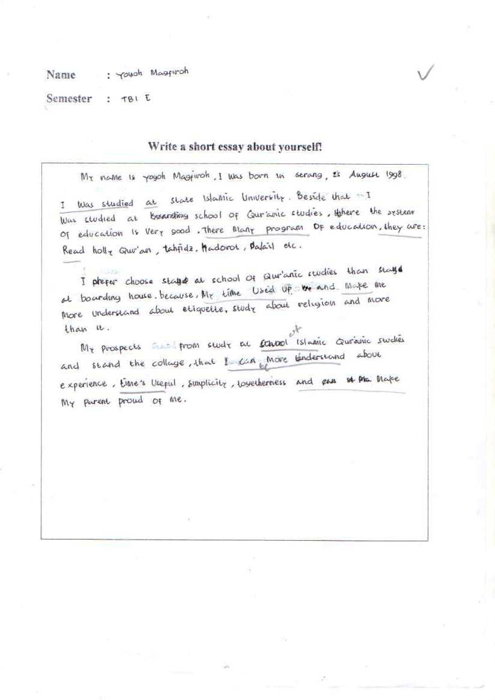
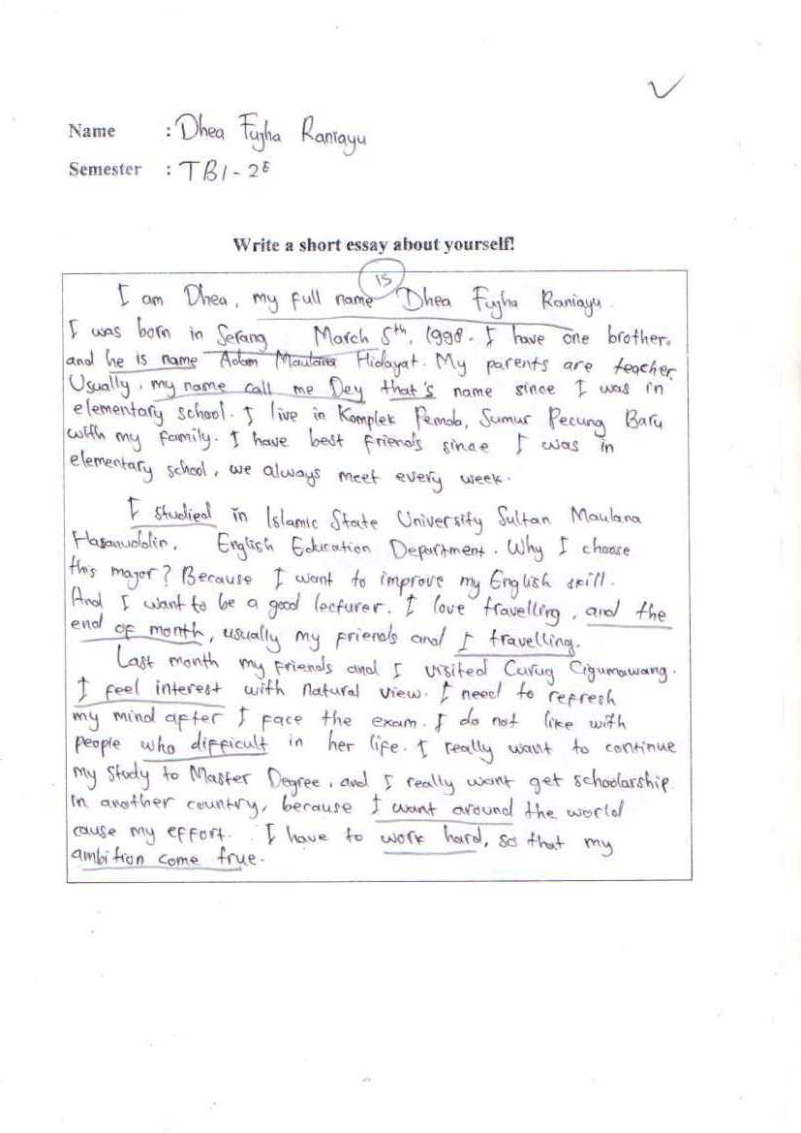
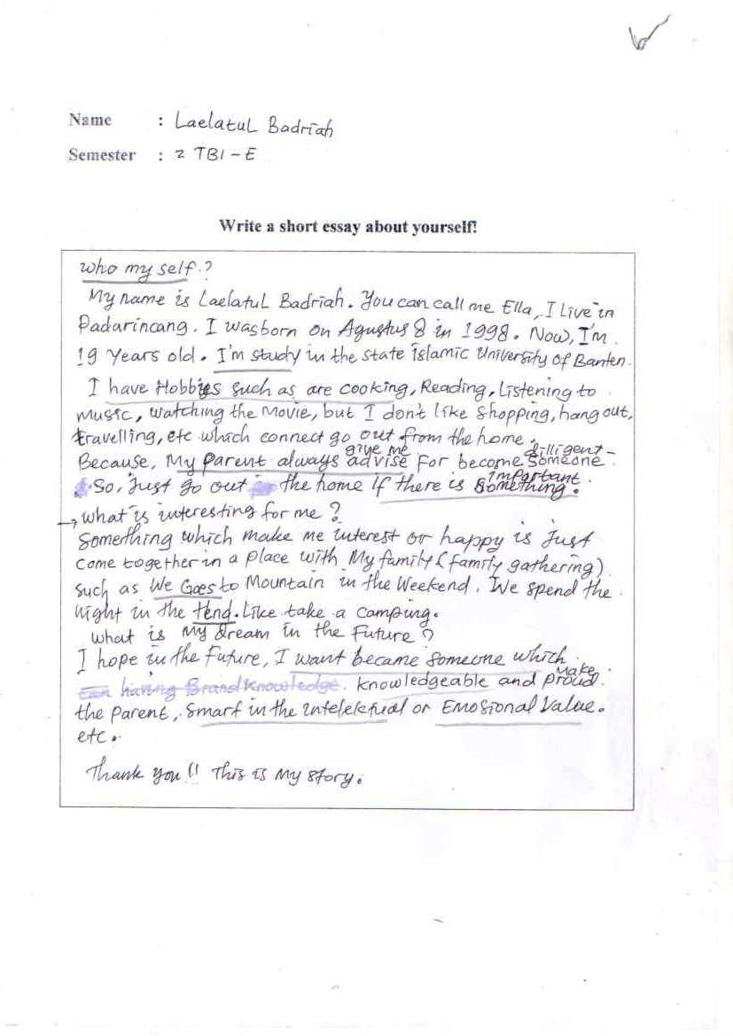
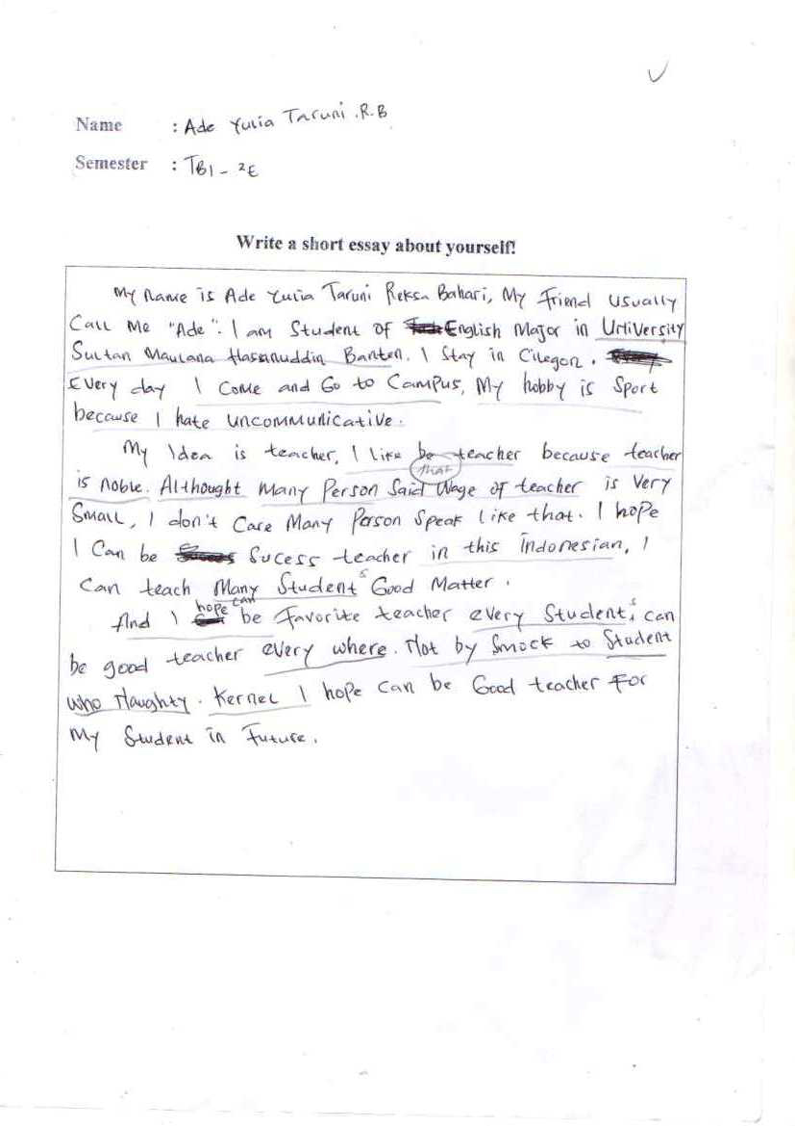
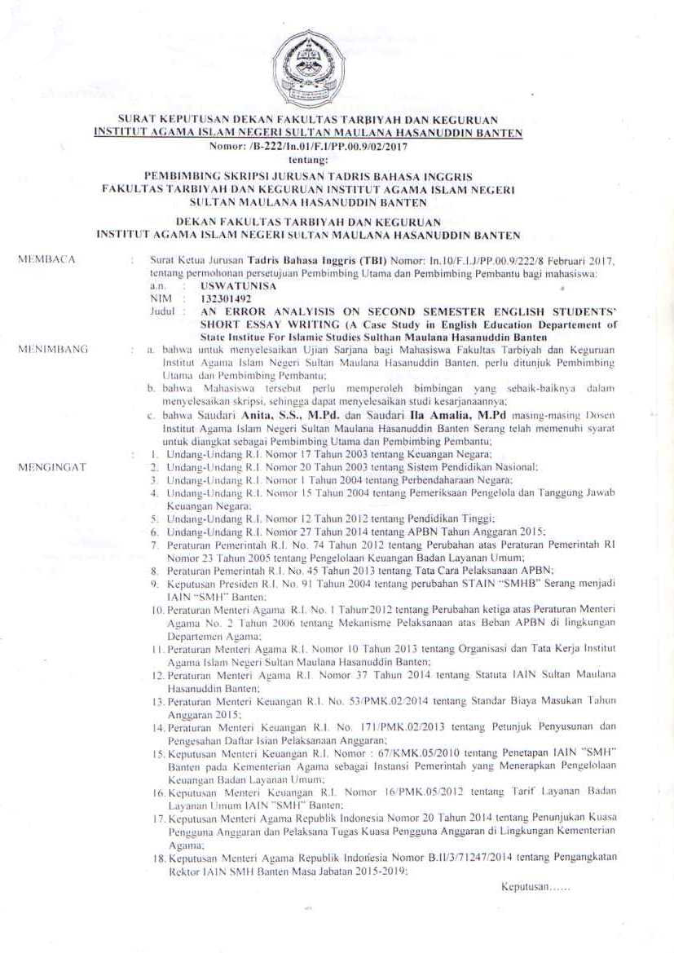
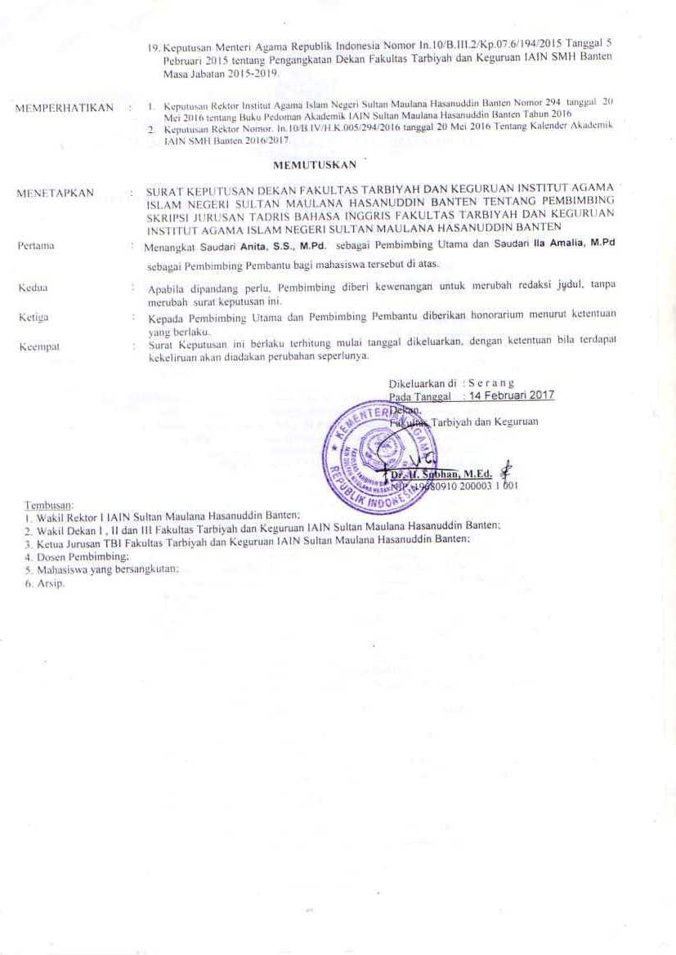
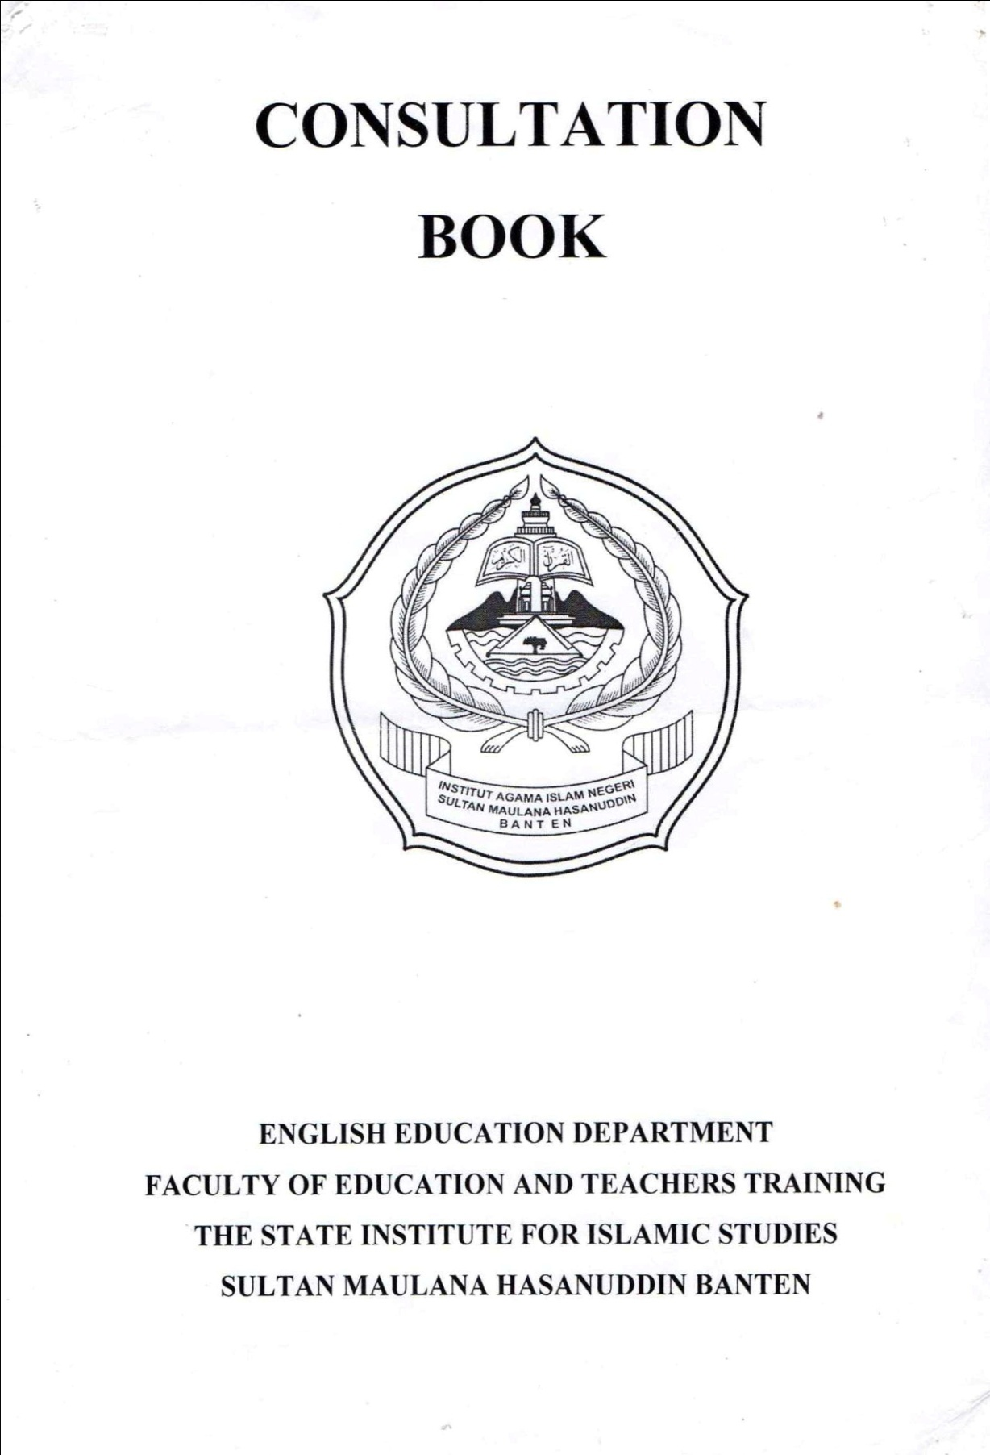
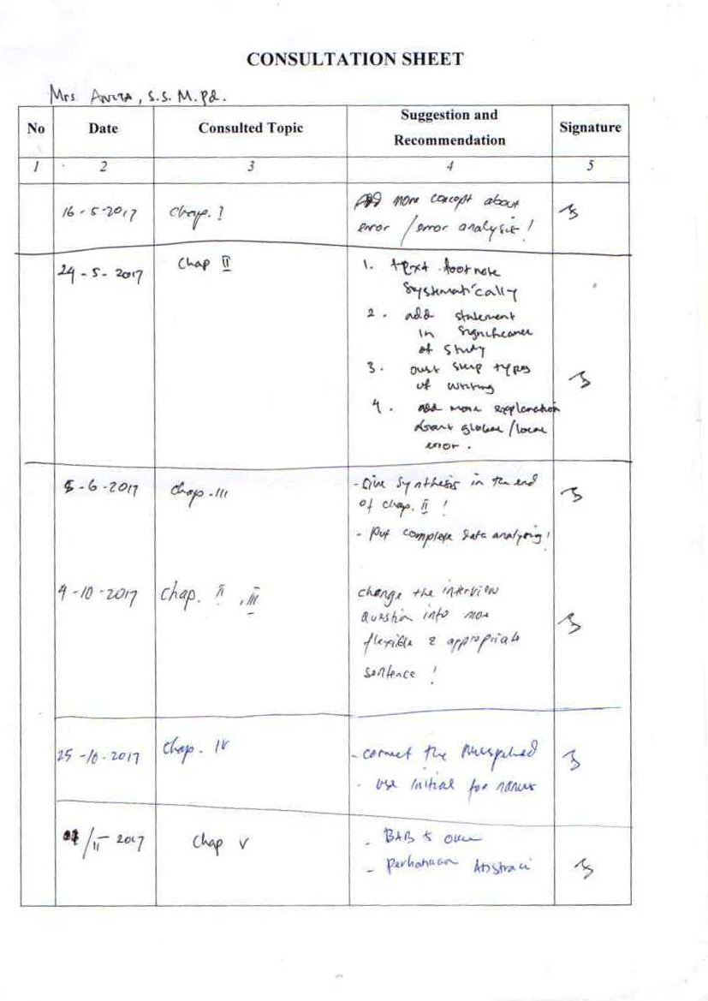
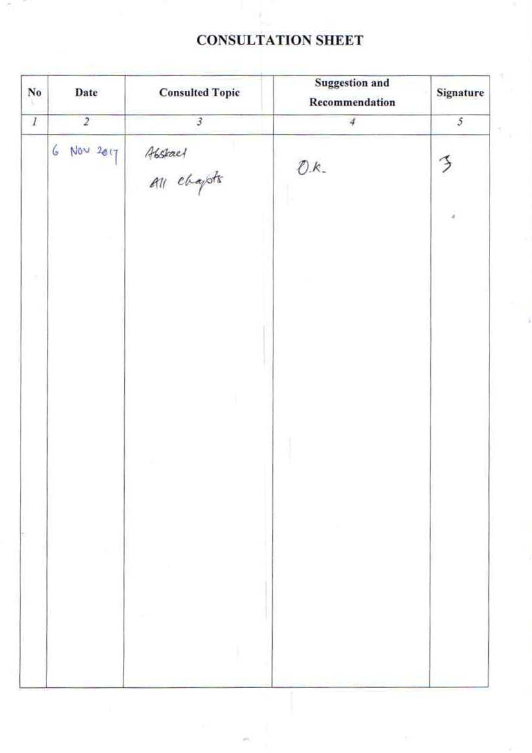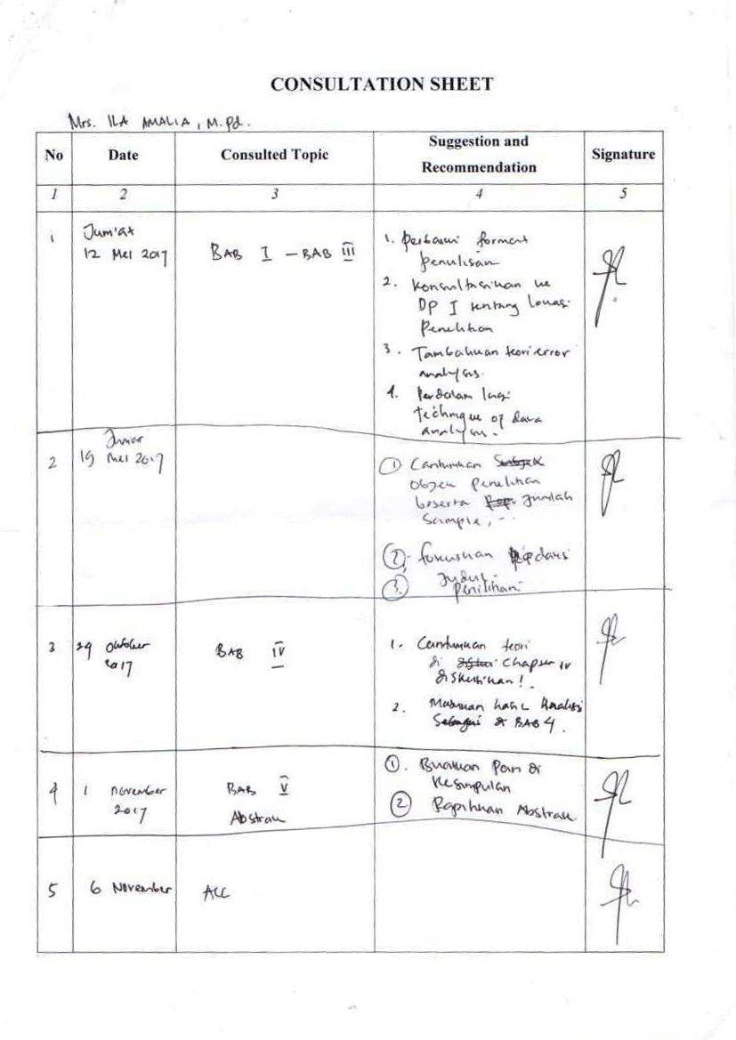

James D. William, The LEA Guide to Composition, (New York: Lawrence Earlbaum Associates, Inc . 2001), 5.
Jack C Richard , Methodology in Language Teaching, (United Kingdom: Cambridge University Press, 2002), 303.
Alice Oshima, Introduction to Academic Writing, (New York and Sydney: Addison-Weshley Publishing Company Inc. 1988), 94 .
Neigel Warburton, The Basic of Essay Writing,(Routledge, 2006) .i
Robet Lado, Language Teaching, (New York: Mc. Graw Hill. Inc. 1964), 35.
Ann Brown and Raymond, Helping Children’s write, (New York: Champan Pubhlising Ltd. 1993), 2.
Penny Ur A, Course in Language Teaching 10th edition, (London: Cambidge University press, 2003), 163.
Wendy A Scott, Teaching English to Children, London and New York (Longman), 69.
Alice Hosima and Ann Hogue, Writing ACADEMIC ENGLISH Third Edition, (Longman),1-12.
Alice Hosima and Ann Hogue, Writing ACADEMIC ENGLISH Third Edition, (Longman),100.
T.W. Adorno, The Essay as Form (JSTOR), 16.
Kathleen T. McWhorter, THE COLLEGE STUDENT’S GUIDE TO WRITING FIVE TYPES OF ESSAYS (Information obtained from Successful College Writing 2nd ed.)
Alice Savage, Patricia Mayer, Effective Academic Writing 2, The Short Essay,(USA: Oxford University Press, 2006), 15.
Guidelines on Writing Short Essays for Every Student _ Rules for College and University Essay Writing.html
Heidi Dulay, et al, Language Two, (UK: Oxfrod University Press, 1982), 138.
H. Douglas Brown, Principles of Language Learning and Teaching, (New York: Longman, 2000), 217.
Brown, Principles of Language Learning and Teaching, 217.
Brown, Principles of Language Learning and Teaching, 218.
S.P. Corder, Error Analysis and Interlanguage, (London: Oxford University Press, 1981), 51.
Brown, Principles of Language Learning and Teaching, 218.
S.P. Corder., Error Analysis and Interlanguage London: Oxford University Press, 1981), 45.
Heidi Dulay, Language Two, (New York: Oxford University Press Inc. 1981), 146.
Dulay. Langauge two. 191.
.P. Corder, Error Analysis and Interlanguage, (London: Oxford University Press, 1981), 36.
John Norrish, Language Learners and Their Errors, (London: Macmillan Press, 1983), 21—26.
Monnipha Sompong, Error Analysis, Language Institute Thammasat University.
David Nunan, Research Methods in Language Learning, (New York: Cambridge University Press, 19920).74
Alison Mackey, Second Language Research (Methodology and Design), (London: Lawrence Erlbaum Associates, Publishers , 2005), 188.
Lexy J. Moeloeng, Metodolgi Penelituan Kualitatif. (Bandung: Remaja Rosdakarya, 1988) , 5.
Ary Donal, et al., Introduction to Research in Education, (Wadsworth, Cengage Learning, 2010), 150
Rod Ellis, Second language acquisition, (New York Oxford University Press, 1997), 15-20.

