CHAPTER III
METHODOLOGY OF THE RESEARCH

- Method of Research
  - Method of research
In doing research, a researcher using a method to collect data form the research which is conducted by the researcher. In this research the researcher chose a classroom action research, because it was suitable based on title of this study (Improving Students’ Reading Comprehension on Fables Through Pictures). Classroom action research begins with a question or questions about classroom experiences, issues. It is reflective process which helps teacher to explore and examine aspects of teaching and learning and to take action to change and improve.
Action research is powerful tool for change an improvement at the local level. Indeed, curt lawn’s own work (one of action’s research founding fathers) was deliberately intended to change the life chances of disadvantaged groups in terms of housing, employment, prejudice, socialization and training.
Another book said that Action research is designed to enhance and improve current Practice within a specific classroom, school, or district. Typically, it is a type of research undertaken by practitioners who have identified problems they wish to solve or who would simply like to find ways to enhance their own teaching or student learning, or both.
There are two types of action research, critical action and practical action research. Critical action research, as described by Freire (1970) is research that is collaborative and is implemented to improve the lives of those who are being studied. Practical action research is conducted in classroom or school settings and provides practitioners the opportunity to identify and solve their own educational problems.
In action research method there are four procedure or steps, those are: planning, action, observation and reflection. The researcher using two cycles of planning step in action research. There are four procedure or steps to conduct the action research. Those are;
- Planning
Based on the identification of problem, the researcher plan the implementation of classroom action research, ranging from materials or teaching materials, lesson plans that include methods / techniques of teaching, as well as techniques and instruments of observation / evaluation, prepared carefully at the planning stage. The aim is that when doing the action in the classroom is progressing well.
The procedures above are steps will be done by research :
- To get legal permission from MA Manbaussalam to conduct this action research.
- To do observation to know condition of teaching and learning process of English lesson in MA Manbaussalam.
- Preparing lesson plans with the model learn to use the read Fables Story.
- Preparing data collection instruments for use in the implementation of action.
- Making observation sheet about the condition of the classroom learning process.
- To design evaluation tool of students’ extensive reading comprehension.
- Acting
In this action, researcher conducted a pre-planned action. The researcher began a process of teaching and learning in the classroom with research method, namely using the method of Fables and the results will also be used to improve teacher performance.
- Observation
In this observation, the researcher observed teaching and learning in the classroom. This observation serves to see and document the effects caused by action in the classroom. Because the observation is an attempt to record the process that occurs during the learning takes place. The observation is done simultaneously with action.
- Reflecting
In this reflection, the researcher conducted the following activities: analysis, interpretation (interpreting), explain and conclude all activities that have taken place. Because the reflection is used to improve the performance of teachers at the next meeting. Thus, the action can not be done in one meeting due to reflection takes time to do it as planning for the next cycle.
  - Design of research
To clear method that used in this research, the researchr give a scheme or action research.
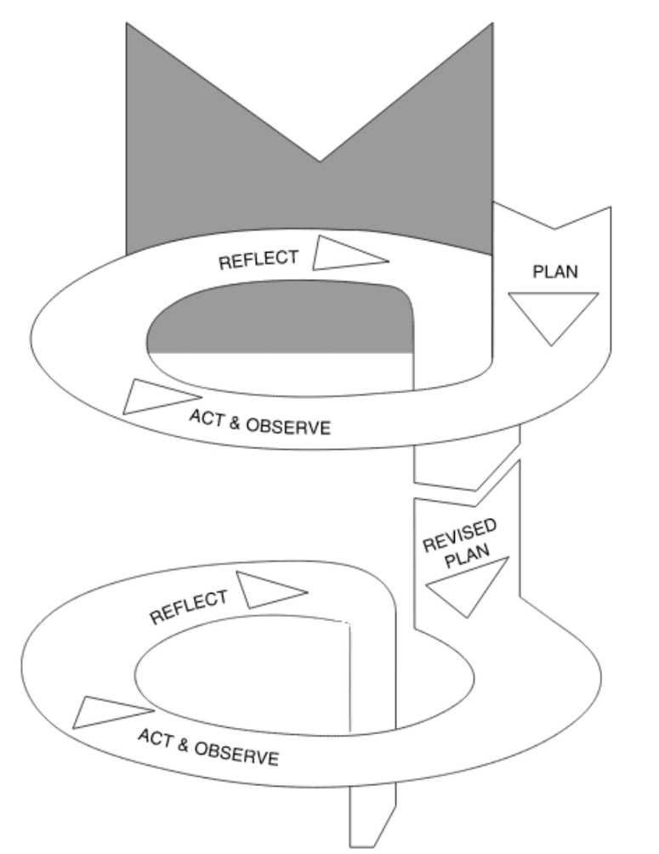
The Spiral of Classroom Action Research By Kemmis and Taggart Figure 3.1

In detail the overall cycle will be described as follows:
- Pre-cycle
Before Classroom action research applied, the researcher is using Pre-cycle to make sure that students have weakness in reading comprehension such as students still have difficulities in analyzing the text content, understanding the meaning of sentences and meaning of word. So, the researcher giving instrument like test.
- Cycle
- Plan
For this step, the researcher prepared everything which needed such as:
- Preparing lesson plan, the material of reading comprehension, the concept of Fables technique. The material that used passages for read simple story for a story of an article or legend story.
- Preparing the material, making lesson plan, and designing the steps in doing the action.
- Preparing list of students’ name and scoring.
- Preparing teaching-purpose.
- Preparing sheets for classroom observation (to know the situation of teaching-learning process when the method applied)

After known the information of condition in teaching and learning process, the researcher plans to use English language when interact with the students, and the researchers to prepare sheet of simple story that will be used later.
- Action
In this cycle the researcher must remember and try to obey what has been formulated in the draft. The researcher explains the material about material which learned. And give to students the sheet of simple story. And give motivation in other to the students enthusiasm to read and understand the text of fables story.
- Observation
The observe activities of classroom teaching and learning process by using the Fables story which focused on the implementation of the reading activities, because the observation is data gathering. In other word, observation is the instrument to show how far the effect of the action.
- Reflection
Evaluating the result of this activity is aimed to know the students’ reading comprehension. Renewing the medium of the learning process based on the previous evaluation. In this step the researcher sets the new lesson plan to renew the action will be done in the cycle II.

- The Location and Time of The Research
The researcher takes this research in MA Manbaussalam Carenang-Serang. The research start from May 10th 2016 until finish. The researcher chooses this school because it is at the downtown. So, it is strategic locations that enable the researcher to conduct the research. Besides, the school is near to the residence of the researcher that also enabling to reach the location.

- Technique of Data Collection
Collecting data is important of this research. Below are some steps that used in this research in other to get valid information that will support the research. There are :
- Test
Test was used to measure the ability of students’ reading comprehension. The researcher uses test that relate to reading comprehension and acquisition. Such essay questions on the text fable stories.
- Observation
Observation is one instruments that used by research in order to know about the class activity. This is process of obtaining the data by observing the teaching and learning process in the classroom.
The researcher used observation while the process of teaching. It is to know the weakness when teaching process on going. Therefore, we should find out the solution to solve it for better in next teaching process reading comprehension on fables through pictures. The researcher conducted the observation students’ activity in teaching learning process.

- Technique of Data Analysis
To analysis the data, the researcher will apply the following steps:
- Collecting and scoring the students’ test sheets
- Computing the percentage of the correct answer on the test
- The students’ score is used to determine the level of their ability in reading comprehension in particular. To score the right answer of the students, the researcher uses this formula;
$$S=\frac{R}{N}×100 \%$$
$$S=Students^{'}score$$
$$R=The sum of the right answer$$
$$N=The sum of the item$$
- To find the mean score, the researcher uses the formula as follow :
$$Mx = \frac{\sum{fx}}{N}$$
$$Mx =Mean score$$
$$\sum{\begin{aligned} =The sum of . . . \\ \end{aligned}}$$
$$fx =The students^{'}score$$
N =The number of students
Table 3.1
The Level to group the students’ score are as follows;
LETTER | VALUE | DESCRIPTION
A | 90 – 100 | Excellent / extremely good
B | 75 – 85 | Good
C | 60 – 74 | Fair / satisfactory
D | 45 – 59 | Low / almost satisfactory
E | 0 – 44 | Extremely low
To find the percentage, the researcher used the formula as follow:
$$P= \frac{f}{N}×100 \%$$
$$P=Persentage$$
$$F=Frequency$$
$$N=The number of cases or students$$

- Indicator
Classroom action research (CAR) is able to be called successful if it can exceed the criterion that has been determined, and fail if it cannot exceed the criterion that has been determined. In this study, the research will succeed when there is 75 % numbers of students could achieve some improvement scores from the evaluation test in the last cycle and they could pass the standard criterion of minimum competence (KKM). The standard criterion of minimum competence that must fulfill considering reading subject is 70 (seventy) which is adapted from the school agreement at MA Manbaussalam Carenang-Serang. If the criterion of the action success reached, it means that the next action of the classroom action research would be stopped, but if the criteria has not been reached yet, the alternative action be done in the next cycle.

Louis Cohen, et al., Research Method in education, (6th.ed) (Canada: Routledge, 2007),,1.
Marguerite G, et, al., Method In Educational Research, From Theory to Practice (Josey-Buss, 2006), 17.
Marguerite G, et, al., Method In Educational Research, From Theory to Practice (Josey-Buss, 2006), 18.
Jean McNiff & Jack whitehead, Participatory Action Research Communicative Action and the Public Sphere (London. 2000). 45.
Anas Sudijono, Pengantar Statistik Pendidikan, (Jakarta: PT Raja Grafindo Persada, 2014), 85.

