THE EFFECTIVENESS OF PROBLEM SOLVING STRATEGY IN TEACHING WRITING OF ARGUMENTATIVE TEXT

Elin Restiani Sunandang
sunandangelin@gmail.com

ABSTRACT
This research designed to find out the effectiveness of Problem Solving Strategy in teaching writing skills on a argumentative text. The research conducted based on the main problems: 1) How is the students' skills in writing English on argumentative text at the second grade of SMA Negeri 6 Kota Serang? 2) How is the effectiveness of using the problem solving strategy in teaching writing on argumentative text at the eleventh grade of SMA Negeri 6 Kota Serang?. This research oriented the following aims: 1) To know the students' skills in writing argumentative text at the eleventh grade of SMA Negeri 6 Kota Serang. 2) To know the effectiveness of using the problem solving strategy in teaching writing on argumentative text at the eleventh grade of SMA Negeri 6 Kota Serang.
The writer used quasi experiment. To answer the questions, the writer collected the spread of data from 62 students spread in two classes, one class as the experimental class and another one as the control class, by applying experimental research method. The population is the eleventh grade of SMA Negeri 6 Kota Serang year 2016/2017, while class XI IPA 4 as the experimental class and class XI IPA 3 as the control class are taken as the sample.
The result of the research show that the hypothesis, that the null hypothesis is rejected, its showed from that significant statistical value 2.00 and significant 5% of 1% 2,66 and the result of t_{o =} 4.12. Based on the data calculating the of t-test that effective of using problem solving strategy in teaching writing on argumentative text has positive effect
Finally, it was suggested that English teacher should have appropriated method in teaching English and be more motivate in order to the students more felt fun when English learning process by using some technique that can make-the students enjoy in their learning
Key Words: Problem Solving Strategy, Teaching Writing, Argumentative Text.

INTRODUCTION
In Indonesia implementation of the education curriculum in primary school, secondary school, and high schools directed at achieving goals has been established. But not all of these goals can be achieved with good, especially for English teaching program. In carrying out activities in addition to learning educators must master the material or teaching material, of course it is also necessary to know how the teaching material was presented and how the characteristics of learners who received the teaching materials. Failure educators in delivering teaching materials is not always due he did not master the teaching material, but because the learners did not know how convey the material properly and appropriately so that learners can learning with fun. So that learners can learn with fun and get maximum learning results, the educators need to have knowledge about what method is right in presenting the teaching materials.
Solving a problem is a basic activity for human. Reality shows most human life is dealing with the problems. We need to find solutions. When we failed in some way to solve the problem, we must try finish it in another way and express it with write it.
Writing is not just for expressing and developing ideas, thoughts and feelings, but writing is a process of an experience that is experienced by the author to be conveyed to the reader and to delivered or know our opinion about problem around us such as newspaper, magazine, etc
As has been said above, everyone has the ability to write, including students, to improve and develop their skills in writing, therefore writing skills should be taught in school or an educational institution. In addition, with the teaching of writing students have expectations to have a paper of their own results.
Based on the observation while teaching practice (PPLK) in SMA Negeri 6 Kota Serang on July until September 2016, there are some students who still less on understanding about the problem around them especially at eleventh grade. They still just been followers on the problem, they can’t to make some solution. That why some of them are still find difficultness to solve the problems especially to write it in a text. Students tend to be lazy and lackluster when faced with the problems so that student learning outcomes not maximal.
By studying the material the students are expected to solve some problems. The purpose is essentially a process consequential human being to tackle the problems faced lifelong. Therefore, students should be completely trained and familiarized think independently and give some solves.

THEORETICAL REVIEW
- Problem solving
According to Suarna, Problem solving method is a method of teaching used by teachers to encourage students to seek and find and solve problems. Problem solving is done by scientific, it means to follow the rules of science as practiced in scientific research.
Dave Francis (1990) “problem solving is how their behaviour differ? And the best way to define the caracteristics of the capable problem solver is to see what competencies they process.” Its mean the problem solving strategy is used to make the student have a good behaviour and more critical in look the problem around them.
Meanwhile, problem solving is one of way to solve a problem, in teaching strategy, its mean the teacher give some problems to student and make them think how to give the solution based on their mind or opinion. The purpose is to make the student have open minded and can give good solution to the problem especially around their life.
Based on Killen (1998) the classroom agenda is as follows: First, the teacher gives an example of an academic descriptive paragraph. Then, he shows that the way the generic structure of the paragraph is written is the frame of a problem situation is solved, so the students understand what they have to do in writing an academic descriptive paragraph, Next, the teacher guides the students to use the data that will help them to solve a problem. After that, the teacher facilitates group processes the problem, After that, the teacher encourages the students' participation. Then, the teacher helps the students to keep on tract on the relevant data. Afterwards, the teacher challenges students' logic and beliefs. At last, the teacher provides constructive feedback to correct erroneous student reasoning. During the process of the strategy, the teachers wisely assumes role of fellow students.
- Writing
Acording to Dorothy and Lisa (2005) “Writing is a very important part of study. You will write assignments that may range from one paragraph to several pages long, and will write answer on test and exams that may be a few sentence long or complate sentence.”
According to Dorothy and Carlos,
Writing is an important form of communication in day-to-day life, but it is especially important in high scholl and college. Writing also one of the most difficult skills to master in both a first language and a second language. Students can find it challenging to find ideas to include their writing, and each culture has its own style for organizing academic writing.

According to John Langan (2010) “Writing is a natural gift, many people believe, mistakenly, and that writing should flow in a simple, straight line from the writer’s head onto, the page.” Meanwhile, writing is a natural gift that important for communication with other people, and also an activity to creating pieces of written work to express their fill to entertain or education. In education, usually writing used for academic assignments and its one of the most difficult skill in english learning so the students need to practice harder to be a master.
- Teaching Writing
Teaching is learning process, it’s based on the teacher. It’s mean that teaching is a process of study from the teacher to the students, it’s not just in the classroom.
Acording to Rajani, “Teaching is a from of interpersonal influence aimed at changing behaviour potential of other person”. Its mean teaching is a process to change someone potential te be better.
      - Writing assessment
There are at least four different sorts of purpose that assessment may serve. First, one may wish to assess whether a particular individual will ever be able to learn any foreign language at all. Anassessment of this kind is an assessment of aptitude. Second, assessment may be made to determine how much English an individual. Third, assessment may be made to determine the extent of student learning, or the extent to which instructional goals have been attained. The four terms aptitude, proficiency, achievement, and diagnostic are very frequent in the literature on testing and it is well to get their meaning clear.
According to H. Douglas Brown
The order in which the five categories (organization, logical development of ideas, grammar, punctuation/ spelling/ mechanics, and style and quality of expression) are listed may bias the evaluator toward the greater importance of organization and logical development as opposed to punctuation and style. But the mathematical assignment of the 100-point scale gives equal weight (a maximum of 20 points) to each of the five major categories.

- Argumentative Text
Laurence Behrens and Leonard J Rosen (2005) categorize syntheses into two main types: explanatory and argument. The easiest way to recognize the difference between the two types may be to consider the difference between a news article and an editorial on the same subject. For the most part, we'd say that the main purpose of the news article is to convey information, and the main purpose of the editorial is to convey opinion or interpretation. It’s mean the argumentative text its used to make some argumentation that gives information from someone opinion that based on data.
Based on theoretical above the author makes the framework as follow:
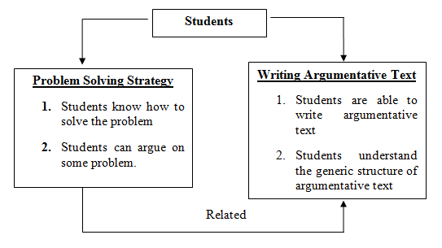
METHODOLOGY OF RESEARCH
Patterns in this study researchers used a quantitative experiment approach, which is to gain significance among the variables studied. Research quantitative is a process of finding knowledge of the use of data be a number as a means of finding information about what we want to know.
Research experiment is a way to find a causal relationship between the two factors that deliberately inflicted by researchers with reducing or set aside other factors that interfere.
The author applied an experimental and control class designed by Arikunto for conducting the result, as followed:
Control group, pre-test, post-test design
E  K | O_{1 x} O₂  O₃ O₄
Where:
E : Experiment Class
K : Control Class
O_{1 &} O₃ : Pre-Test
X : Treatment
O_{2 &} O₄ : Post-Test
In this research the author take place in SMA Negeri 6 Serang City, its located in Jl. Raya Petir Km. 04 Kelurahan Cipocok Jaya, Kecamatan Cipocok Jaya, Kota Serang Provinsi Banten. 42121. Phone (0254) 216380.
Population is a generalization that region of the object / subject have certain qualities and characteristics defined by the researchers to learn and then drawn conclusions. . The population in this research students of class XI IPA 1-4 and IPS 1-4 SMAN 6 Serang City are 278 students with 104 Male and 174 Female in Lesson Year 2016/2017.
The sample is part of the number and characteristics possessed by the population. For techique sampling, Researcher use purposive sampling because its looked by the purpose the research that need two classes for control class and treatment class.
The researcher take two classes as sample are class XI IPA 3 as a class experiment with a number of 30 students and class XI IPA 4 as the control class with the number of 32 students. Then, it can be seen that this sample amounted to 62 students.
In accordance with the necessary data in this study, the technique Data collection in this study include : Tests ( Pre – Test and Post – Test ), and Documentation.
Then the author uses some techniques to analysis the data, as follow: Collecting data. The data are taken from the sample data is from student’s exercise of argumentative text. ; Identify Error. The data are then identified. The identification is in the form of student’s errors of language feature in constructing a argumentative text. ; Analysis data by using statistic calculation of Test formulas with the degree of significance 5% and 1% stated Suharsimi Arikunto with the Calculation T-Test as bellow :
t = $\frac{Mx-My}{\sqrt{\left(\frac{Ʃx^{2}+ Y^{2}}{Nx+Ny-2}\right)\left(\frac{1}{Nx}+ \frac{1}{Ny}\right)}}$

Notes:
Mx = Mean of experiment class
My = Mean of control class
ƩX² = the total square of error in experiment class
ƩY² = the total square of error in control class
N = the number of subject
Df = Degree of freedom

RESULT
The writer analysis the data by comparing students’ score in pre-test and post-test in experimental class, Note the graphic below:
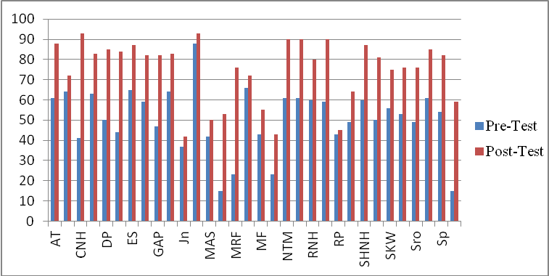
Graphic 1
The diffe rent score between pre- and post- Test of experiment class

Graphic 1 above showed that the results of the students' pre-testThen, The writer analysis the data by comparing students’ score in pre-test and post-test at control class, explaining by the graphic below:
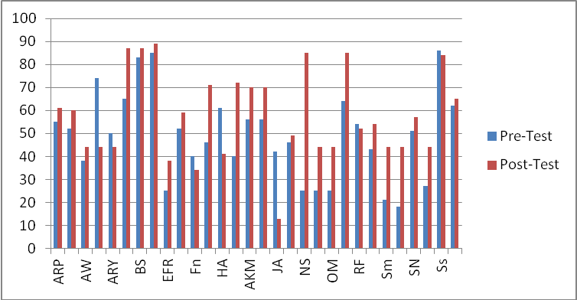
Graphic 2
The different score between pre- and post- Test of experiment class

To know the effectiveness of problem solving strategy students' writing skills on argumentative text, the writer gave the test to students as the sample both at the experimental class and at control class. The test used in this research divided into two types, there are pre-test and post-test.

The writer t-test calculated using the steps as follow:
        - Determine mean of score experiment class (MX), with formula:
MX = $\frac{ƩX}{N}$
=$\frac{777}{32}$
= 24.28

        - Determine mean of control class (MX), with formula:
MY = $\frac{ƩY}{N}$
= $\frac{263}{30}$
= 8.93
        - Determine the total square of error in experiment class (X), with formula:
ƩX² = ƩX² – $\frac{{(ƩX)}^{2}}{N}$
= 24145 - $\frac{{(777)}^{2}}{32}$
= 24145 – $\frac{603729}{32}$
=24145 – 18866.53
= 5278.47
        - Determine the total square of error in control class (Y), with formula:
ƩY² = ƩY² - $\frac{ƩY2}{N}$
= 11564 – $\frac{{\left(268\right)}^{2}}{30}$
= 11564 – $\frac{71824}{30}$
= 11564 – 2394.13
= 9169.87
        - Calculation T-Test
$$t = \frac{Mx-My}{\sqrt{\left(\frac{Ʃx^{2}+ Y^{2}}{Nx+Ny-2}\right)\left(\frac{1}{Nx}+ \frac{1}{Ny}\right)}}$$
$$t = \frac{24.59-8.93}{\sqrt{\left(\frac{5278.44+ 9169.87}{32+30-2}\right)\left(\frac{1}{32}+ \frac{1}{30}\right)}}$$
$$t = \frac{15.66}{\sqrt{\left(\frac{14448}{60}\right)\left(0,06\right)}}$$
$$t = \frac{15.66}{\sqrt{\left(240.8\right)\left(0.06\right)}}$$
$$t = \frac{15.66}{\sqrt{14.448}}$$
$$t = \frac{15.66}{3.80}$$
$$t = 4.12$$
        - Determine the degree of freedom, with formula:
Df = Nx + Ny – 2
= 32 + 30 – 2
= 60
The result above showed about the score of sample both experiment and control class. The writer used 62 students as a sample for the research. 32 students are from XI IPA4 as experimental class and 30 students are from XI IPA3 as control class.
Comparing “t” has been tasted in calculating (t_{o} = 4.12) and df (degree of freedom) for 60, the writer used the closer “df” from 62-2 = 60. So, df=60 which has been tested on t-table (t_{t} = 5%=2.00 and t_{t} = 1%=2.66). It can be known that t_{o}>t_{t} 5% and t_{o} >1% its means 2.00<4.12>2.66.
From the above interpretation t-count > t-table means there was significance effect of using problem solving strategy to increase writing skills. Testing hypothesis was to know the significant of bo variables, and tested as follows:
Ha = t_{o}>t_{t}
Ho= t_{o}<t_{t}
Notes:
H_{a} = Alternative Hypothesis
H₀ = Null Hypothesis
t₀ = the value of t-observation
t_{t} = the value of t-table
From the result conclusion above, the value of t_{o} = 4.12 the degree of freedom (df) = 60. The writer use degree of significant 5%= 2.00 and 1%=2.66. Its mean that Ha (Alternative Hypothesis) of the research is accepted and H₀ (Null Hypothesis) of the research is rejected.
After getting the data, the writer compared both degree of significant 5% and 1% t_{o}>t_{t} 5% and t_{o}>t_{t} 1%, 2.00<4.12>2.66. It means (Alternative Hypothesis) of the research is accepted.

CLOSING
The researcher concludes that students writing argumentative text at the second grade of SMA Negeri 6 Kota Serang before given the treatment are low. And there was effectiveness of using the problem solving strategy students' writing skills on argumentative text, it can be seen from the result of the post-test is higher than pre-test students. And the result of the calculation of data it is shown t-table of 5% and 1% are significant, 2.00 <4.12 2.66.
Based on conclusion above, the writer would gave some suggestions as follow: The teachers should be more creative and innovative in teaching the students so they can get more motivate and interest to study English subject and can improve their skill in English. ; The student more felt fun when English learning process by using some techniques that can make them enjoy the subject. ; And the last one, for the next writer that will conduct about using problem solving strategy for students writing skill on argumentative text, the writer hope that the next writer will make it on different text.

BIBLIOGRAPHY

Ahmad, Zafafar S and Ahmed Shakeel K, “Role of Teacher in Personal Learning Environment,” 21 June 2012, http://greav.ub.edu/der/

Arikunto, Suharsimi. Prosedur Penelitian Suatu Pendekatan Praktik. Jakarta: PT Rineka, 2010.

Arikunto. Suharsimi, Menejement Penelitian. Jakarta: Rineka.

B, Geoffery, B Christopher, F Roger, et al, Teaching English as Foreign Language. France: Rutledge Press, 2003.

Behrens, Laurence and J, Leonard Rosen, A Sequence for Academic Writing, United State : Longman, 2010.
Brown, Douglas. Language Assessment Principles and Classroom Practices. Sanfansisco : Longman, 2004.

Douglas, H. Brown, Language Assessment Principles and Classroom Practice. New York: Pearson Education, 2004.

E, Dorothy Zemach and Carlos Islam, Paragraph Writing in Paragraph. Macmillan, 2005.

E, Doroty Zemach and Lisa A Rumisek. Academic Writing from Paragraph to Essay. Spain: Macmillan Publishers, 2005.

Francis, Dave, Effective Problem Solving, ( Routledge: London, 1990)

Fredericks, Anthony D. The Teacher's Handbook: Strategies for Success.New York:R&L Education, 2010.

Harmer, Jeremy. How to Teach English. England: Longman, 2007.

Harmer, Jeremy. How to Teach English. Pearson Eduction Limited, 2007.

Huda, Miftahul, Model-Model Pengajaran dan Pembelajaran Isu-Isu Metodis dan Pragmatis,. Malang : Pustaka Pelajar, 2014.

Killen, Roy. Effective teaching strategies: Lessons from research and practice. Learning Australia: Cengage 2006.
Komariah, Euis and Emiliya SDD. “The Correlation Between Student Understanding on Present Tense and Student Ability on Writing Analytical Exposition”, Asses English Education Journal, Vol. II, No. 2, (January-June, 2016)

Langan, John. English Skills With Readings, New York : Mc Graw Hill, 2010.
Mariam, Mariam-Webster, 1828. http://www.meriam-webster.com/dictionary/argument.

N. Roestiyah.k. Didaktik Metodik. Jakarta: Bumi Askara, 1998.

Nation, I.S.P. Teaching ESL/EFL Reading and Writing. New York: Routledge, Taylor& France 2009.
Putri, Mayang P, “Pengaruh Metode Problem Solving Terhadap Hasil Belajar Siswa Kleas VIII Mts. Assyarifi’as Gondang Pada Materi Hubungan Sudut Pusat, Panjang Busur, dan Luas Juring dalam Pemecaan Masalah”. S.Pd. Paper, The State Institute Islamic Studies Tulung Agung, 2014.

Quine, Van Willard Orman. Philosophy of logic. London: Harvard University Press, 1986

Reddy, Krlshna, 17 Advantages and Disadvantages of Team Problem Solving. http://content.wisestep.com/top-advantages-disadvantages-team-problem-solving/.

Rijani. Improve Your English, http://www.indiastudychannel.com/forum/79268-what-definition-teaching.aspx.

Robert, Gary Muschla, Exploring Writing. Mc Graw Hill, 2011.

Romiyatul, Syarifah U and As’ari. “Using Picture in Teaching Students’ Descriptive Writing”, ASSES English Education Journal, Vol. I, No 2, (July-December, 2015)

Russell, William, Stewart Waters, and Thomas Turner. Essentials of middle and secondary social studies. New York: Routledge, 2013.

Sagala, Syaiful. Konsep dan Makna Pendidikan. Bandung: Alfabeta, 2005.

Siahaan Sanggam. Issues in Linguistic. Yogyakarta : Graha Ilmu, 2008

Sugiyono. Metode Penelitian Pendidikan, Bandung: Alfabeta: 2010.

Suprijono, Agus. Cooperative Learning Teori dan Aplikasi PAIKEM. Yogyakarta : Pustaka Pelajar, 2015

Suwarna, et al, Teaching Micro. Tiara Discourse: Yogyakarta, 2006

Tanzeh, Ahmad. Metodelogi Penelitian Praktis. Yogyakarta : Teras, 2011.

Tindale, Christopher W. Rhetorical argumentation: Principles of theory and practice. Sage, 2004.

Undang-Undang Republik Indoenesia Nomor20tahun 2003 tentang Sindiknas & PP RI Nomor 47 tahun 2008 tentang belajar mengajar. http://sindikker.dikti.go.iddok/UU/UU20-2003-Sindiknas.pdf.

Syaiful Sagala, Konsep dan Makna Pendidikan, (Bandung: Alfabeta, 2005), p 1.
Syaiful Sagala, Konsep, p 1.
Suwarna, et al, Teaching Micro , (Yogyakarta: Tiara Discourse, 2006), p 114.
Dave Francis, Effective Problem Solving, ( Routledge: London, 1990), p 6
Sanggam Siahaan, Issues in Linguistic, p 222
Doroty E Zemach and Lisa A Rumisek, Academic Writing from Paragraph to Essay, Spain: Macmillan Publishers, 2005), p v
Dorothy E Zemach and Carlos Islam, Paragraph Writing in Paragraph, (Macmillan, 2005), p.iv
John Langan. English Skills With Readings, (New York : Mc Graw Hill, 2010) p 15
Agus Suprijono, Cooperative Learning Teori dan Aplikasi PAIKEM, (Yogyakarta : Pustaka Pelajar, 2015), p 12
Rijani, Improve Your English, http://www.indiastudychannel.com/forum/79268-what-definition-teaching.aspx. Publish in 26 0ktober 2011.
Geoffery B, Christopher B, Roger F, et al, Teaching English as Foreign Language, (France: Rutledge Press, 2003) ,p 157-159
H. Douglas Brown, Language Assessment Principles and Classroom Practice, (New York: Pearson Education, 2004), p. 243
Laurence Behrens and Leonard J Rosen, A Sequence for Academic Writing, (United State : Longman, 2010), p 90
Suharsimi Arikunto, Prosedur Penelitian Suatu Pendekatan Praktik (Jakarta: PT Rineka, 2010), p.9
Sugiyono, Metode Penelitian Pendidikan, (Bandung, Alfabeta: 2010) p. 117-118

