THE EFFECTIVENESS OF COLL ABORATIVE LEARNING TOWARD STUDENTS’ READING COMPREHENSION
(An Experimental Research at the Eight Grade of SMPI Darul Falah Serang-City in Academic Year 2016-2017)

A PAPER
Submitted to the English Education Department,
The Faculty of Education and Teacher Training as a Partial
Fulfillment of the Requirement for the “Sarjana” Degree

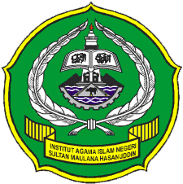
By:
DEDE SUPARDI
SRN: 122301289

FACULTY OF EDUCATION AND TEACHER TRAINING
THE STATE INSTITUTE FOR ISLAMIC STUDIES
SULTAN MAULANA HASANUDDIN BANTEN
2016 A.D. / 1438 A.H.

