THE EFFECTIVENESS OF INSIDE-OUTSIDE CIRCLE (IOC) TECHNIQUE IN LEARNING SPEAKING
(An Experiment Research at Grade VIII of SMP YP Fatahillah Cilegon)

A PAPER
Submitted to the English Education Department,
The Faculty of Education and Teacher Training as a Partial
Fulfillment of The Requirements for The ‘Sarjana’ Degree

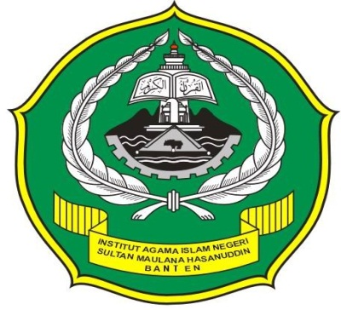

By:
MONIK CHAPRIATI
SRN: 122301296

FACULTY OF EDUCATION AND TEACHERS TRAINING
THE STATE INSTITUTE FOR ISLAMIC STUDIES
SULTAN MAULANA HASANUDDIN BANTEN
2016/2017

